CompTIA CV0-004 - CompTIA Cloud+ Exam
Question #1
(
Topic: Exam A
)
A software engineer needs to transfer data over the internet using programmatic access while also being able to query the data. Which
of the following will best help the engineer to complete this task?
A. SQL
B. Web sockets
C. RPC
D. GraphQL
Answer:
D
Question #2
(
Topic: Exam A
)
Which of the following is a field of computer science that enables computers to identify and understand objects and people in images
and videos?
A. Image reconstruction
B. Facial recognition
C. Natural language processing
D. Computer vision
Answer:
D
Question #3
(
Topic: Exam A
)
A company needs to deploy its own code directly in the cloud without provisioning additional infrastructure. Which of the following is
the best cloud service model for the company to use?
A. PaaS
B. SaaS
C. IaaS
D. XaaS
Answer:
A
Question #4
(
Topic: Exam A
)
A company just learned that the data in its object storage was accessed by an unauthorized party. Which of the following should the
company have done to make the data unusable?
A. The company should have switched from object storage to file storage.
B. The company should have hashed the data.
C. The company should have changed the file access permissions.
D. The company should have encrypted the data at rest.
Answer:
D
Question #5
(
Topic: Exam A
)
A customer relationship management application, which is hosted in a public cloud IaaS network, is vulnerable to a remote command
execution vulnerability. Which of the following is the best solution for the security engineer to implement to prevent the application from
being exploited by basic attacks?
A. IPS
B. ACL
C. DLP
D. WAF
Answer:
D
Question #6
(
Topic: Exam A
)
Which of the following is a difference between a SAN and a NAS?
A. A SAN works only with fiber-based networks.
B. A SAN works with any Ethernet-based network.
C. A NAS uses a faster protocol than a SAN.
D. A NAS uses a slower protocol than a SAN.
Answer:
D
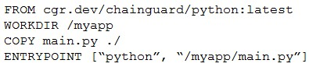
Question #7
(
Topic: Exam A
)
A cloud engineer is troubleshooting an application that consumes multiple third-party REST APIs. The application is randomly
experiencing high latency. Which of the following would best help determine the source of the latency?
A. Configuring centralized logging to analyze HTTP requests
B. Running a flow log on the network to analyze the packets
C. Configuring an API gateway to track all incoming requests
D. Enabling tracing to detect HTTP response times and codes
Answer:
D
Question #8
(
Topic: Exam A
)
A cloud engineer is reviewing the following Dockerfile to deploy a Python web application:
Which of the following changes should the engineer make to the file to improve container security?
A. Add the instruction USER nonroot.
B. Change the version from latest to 3.11.
C. Remove the ENTRYPOINT instruction.
D. Ensure myapp/main/py is owned by root.
Answer:
A
Question #9
(
Topic: Exam A
)
A group of cloud administrators frequently uses the same deployment template to recreate a cloud-based development environment.
The administrators are unable to go back and review the history of changes they have made to the template. Which of the following
cloud resource deployment concepts should the administrator start using?
A. Drift detection
B. Repeatability
C. Documentation
D. Versioning
Answer:
D
Question #10
(
Topic: Exam A
)
A government agency in the public sector is considering a migration from on premises to the cloud. Which of the following are the most
important considerations for this cloud migration?
(
Choose two.
)
A. Compliance
B. IaaS vs. SaaS
C. Firewall capabilities
D. Regulatory
E. Implementation timeline
F. Service availability
Answer:
AD
Question #11
(
Topic: Exam A
)
A company wants to optimize cloud resources and lower the overhead caused by managing multiple operating systems. Which of the
following compute resources would be best to help to achieve this goal?
A. VM
B. Containers
C. Remote desktops

D. Bare-metal servers
Answer:
B
Question #12
(
Topic: Exam A
)
A company runs a discussion forum that caters to global users. The company
’
s monitoring system reports that the home page suddenly
is seeing elevated response times, even though internal monitoring has reported no issues or changes. Which of the following is the
most likely cause of this issue?
A. Cryptojacking
B. Human error
C. DDos
D. Phishing
Answer:
C
Question #13
(
Topic: Exam A
)
Which of the following migration types is best to use when migrating a highly available application, which is normally hosted on a local
VM cluster, for usage with an external user population?
A. Cloud to on-premises
B. Cloud to cloud
C. On-premises to cloud
D. On-premises to on-premises
Answer:
C
Question #14
(
Topic: Exam A
)
A cloud architect attempts to modify a protected branch but is unable to do so. The architect receives an error indicating the action
cannot be completed. Which of the following should the architect try instead?
A. Adding a new remote
B. Creating a pull request
C. Merging the branch
D. Rebasing the branch
Answer:
B
Question #15
(
Topic: Exam A
)
Which of the following container storage types loses data after a restart?
A. Object
B. Persistent volume
- Ephemeral
- Block

Answer: C
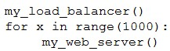
Question #16
(
Topic: Exam A
)
A developer is testing code that will be used to deploy a web farm in a public cloud. The main code block is a function to create a load
balancer and a loop to create 1,000 web servers, as shown below:
The developer runs the code against the company
’
s cloud account and observes that the load balancer is successfully created, but only
100
web servers have been created. Which of the following should the developer do to fix this issue?
A. Request an increase of instance quota.
B. Run the code multiple times until all servers are created.
C. Check the my_web_server
()
function to ensure itis using the right credentials.
D. Place the my_load_balancer
()
function after the loop.
Answer:
A
Question #17
(
Topic: Exam A
)
Following a ransomware attack, the legal department at a company instructs the IT administrator to store the data from the affected
virtual machines for a minimum of one year.
Which of the following is this an example of?
A. Recoverability
B. Retention
C. Encryption
D. Integrity
Answer:
B
Question #18
(
Topic: Exam A
)
An engineer made a change to an application and needs to select a deployment strategy that meets the following requirements:
Is simple and fast
Can be performed on two identical platforms
Which of the following strategies should the engineer use?
A. Blue-green
B. Canary
C. Rolling
D. In-place
Answer:
A
Question #19
(
Topic: Exam A
)
An organization needs to retain its data for compliance reasons but only when required. Which of the following would be the most cost-
effective type of tiered storage?
A. Warm
B. Hot
C. Archive
D. Cold
Answer:
C
Question #20
(
Topic: Exam A
)
An e-commerce store is preparing for an annual holiday sale. Previously, this sale has increased the number of transactions between two
and ten times the normal level of transactions. A cloud administrator wants to implement a process to scale the web server seamlessly.
The goal is to automate changes only when necessary and with minimal cost.
Which of the following scaling approaches should the administrator use?
A. Scale horizontally with additional web servers to provide redundancy.
B. Allow the load to trigger adjustments to the resources.
C. When traffic increases, adjust the resources using the cloud portal.
D. Schedule the environment to scale resources before the sale begins.
Answer:
B
Question #21
(
Topic: Exam A
)
Which of the following vulnerability management phases includes the process of discovering newly introduced security vulnerabilities?
A. Scanning
B. Identification
C. Reporting
D. Remediation
Answer:
A
Question #22
(
Topic: Exam A
)
A developer sends multiple requests to a SaaS application in a short amount of time. The developer realizes that the entire server and all
other users can no longer send requests to the application. Which of the following best describes the issue?
A. Service quotas
B. API rate limiting

- Full outage
- Regional service availability

Answer: B
Question #23
(
Topic: Exam A
)
A cloud engineer needs to integrate a new payment processor with an existing e-commerce website. Which of the following technologies
is the best fit for this integration?
A. RPC over SSL
B. Transactional SQL
C. REST API over HTTPS
D. Secure web socket
Answer:
C
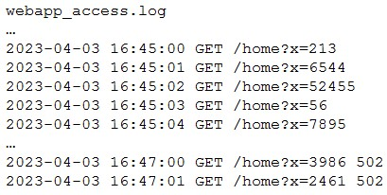
Question #24
(
Topic: Exam A
)
A company
’
s website suddenly crashed. A cloud engineer investigates the following logs:
Which of the following is the most likely cause of the issue?
A. SQL injection
B. Cross-site scripting
C. Leaked credentials
D. DDoS
Answer:
D
Question #25
(
Topic: Exam A
)
Which of the following best describes a characteristic of a hot site?
A. Servers in the hot site are clustered with the main site.
B. Network traffic is balanced between the main site and hot site servers
C. Offline server backups are replicated hourly from the main site
D. All servers are replicated from the main site in an online status.
Answer:
D
Question #26
(
Topic: Exam A
)
Five thousand employees always access the company
’
s public cloud-hosted web application on a daily basis during the same time frame.
Some users have been reporting performance issues while attempting to connect to the web application. Which of the following is the
best configuration approach to resolve this issue?
A. Scale vertically based on a trend.
B. Scale horizontally based on a schedule.
C. Scale vertically based on a load.
D. Scale horizontally based on an event.
Answer:
B
Question #27
(
Topic: Exam A
)
A cloud engineer is reviewing a disaster recovery plan that includes the following requirements:
System state, files, and configurations must be backed up on a weekly basis.
The system state, file, and configuration backups must be tested annually.
Which of the following backup methods should the engineer implement for the first week the plan is executed?
A. Differential
B. Incremental
C. Snapshot
D. Full
Answer:
D
Question #28
(
Topic: Exam A
)
Which of the following is a direct effect of cloud migration on an enterprise?
A. The enterprise must reorganize the reporting structure.
B. Compatibility issues must be addressed on premises after migration.
C. Cloud solutions will require less resources than on-premises installations.
D. Utility costs will be reduced on premises.
Answer:
D
Question #29
(
Topic: Exam A
)
A company wants to create a few additional VDIs so support vendors and contractors have a secure method to access the company's
cloud environment. When a cloud administrator attempts to create the additional instances in the new locations, the operation is
successful in some locations but fails in others. Which of the following is the most likely reason for this failure?
A. Partial service outages
B. Regional service availability
- Service quotas
- Deprecation of functionality

Answer: B
Question #30
(
Topic: Exam A
)
An administrator used a script that worked in the past to create and tag five virtual machines. All of the virtual machines have been
created; however, the administrator sees the following results:
{
tags
: []}
Which of the following is the most likely reason for this result?
A. API throttling
B. Service quotas
C. Command deprecation
D. Compatibility issues
Answer:
C
Question #31
(
Topic: Exam A
)
A cloud administrator needs to collect process-level, memory-usage tracking for the virtual machines that are part of an autoscaling
group. Which of the following is the best way to accomplish the goal by using cloud-native monitoring services?
A. Configuring page file/swap metrics
B. Deploying the cloud-monitoring agent software
C. Scheduling a script to collect the data
D. Enabling memory monitoring in the VM configuration
Answer:
B
Question #32
(
Topic: Exam A
)
A cloud developer is creating a static website that customers will be accessing globally. Which of the following services will help reduce
latency?
A. VPC
B. Application load balancer
C. CDN
D. API gateway
Answer:
C
Question #33
(
Topic: Exam A
)
A cloud engineer is designing a cloud native, three-tier application. The engineer must adhere to the following security best practices:
Minimal services should run on all layers of the stack.
The solution should be vendor agnostic.
Virtualization could be used over physical hardware.
Which of the following concepts should the engineer use to design the system to best meet these requirements?
A. Virtual machine
B. Microservices
C. Fan-out
D. Cloud-provided managed services
Answer:
B
Question #34
(
Topic: Exam A
)
A cloud solutions architect needs to have consistency between production, staging, and development environments. Which of the
following options will best achieve this goal?
A. Using Terraform templates with environment variables
B. Using Grafana in each environment
C. Using the ELK stack in each environment
D. Using Jenkins agents in different environments
Answer:
A
Question #35
(
Topic: Exam A
)
A healthcare organization must follow strict compliance requirements to ensure that PII is not leaked. The cloud administrator needs to
ensure the cloud email system can support this requirement. Which of the following should the organization enable?
A. IPS
B. DLP
C. ACL
D. WAF
Answer:
B
Question #36
(
Topic: Exam A
)
A company
’
s content management system
(
CMS
)
service runs on an IaaS cluster on a public cloud. The CMS service is frequently
targeted by a malicious threat actor using DDoS.
Which of the following should a cloud engineer monitor to identify attacks?
A. Network flow logs
B. Endpoint detection and response logs
C. Cloud provider event logs
D. Instance syslog

Answer:
A
Question #37
(
Topic: Exam A
)
Which of the following is the most cost-effective way to store data that is infrequently accessed?
A. Cold site
B. Hot site
C. Off-site
D. Warm site
Answer:
C
Question #38
(
Topic: Exam A
)
Which of the following models will best reduce the cost of running short-term, non-critical workloads?
A. Reserved
B. Spot instance
C. Pay-as-you-go
D. Dedicated host
Answer:
B
Question #39
(
Topic: Exam A
)
Which of the following vulnerability management concepts is best defined as the process of discovering vulnerabilities?
A. Scanning
B. Assessment
C. Remediation
D. Identification
Answer:
A
Question #40
(
Topic: Exam A
)
Which of the following types of storage provides the greatest performance advantage for a traditional relational database?
A. File
B. Object
C. Block
D. Ephemeral
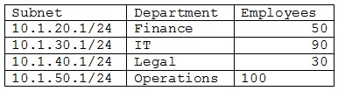
Answer:
C
Question #41
(
Topic: Exam A
)
A cloud networking engineer is troubleshooting the corporate office
’
s network configuration. Employees in the IT and operations
departments are unable to resolve IP addresses on all devices, and the IT department cannot establish a connection to other
departments
’
subnets. The engineer identifies the following configuration currently in place to support the office network:
Each employee needs to connect to the network with a maximum of three hosts. Each subnet must be segregated, but the IT department
must have the ability to communicate with all subnets. Which of the following meet the IP addressing and routing requirements?
(
Choose two.
)
A. Modifying the subnet mask to 255.255.254.0 for IT and operations departments
B. Configuring static routing to allow access from each subnet to 10.1.40.1
C. Modifying the BYOD policy to reduce the volume of devices that are allowed to connect to the corporate network
D. Configuring static routing to allow access from 10.1.30.1 to each subnet
E. Combining the subnets and increasing the allocation of IP addresses available to support three hosts for each employee
F. Modifying the subnet mask to 255.255.255.128 for the IT and operations departments
Answer:
AD
Question #42
(
Topic: Exam A
)
Which of the following compute resources is the most optimal for running a single scripted task on a schedule?
A. Bare-metal server
B. Managed container
C. Virtual machine
D. Serverless function
Answer:
D
Question #43
(
Topic: Exam A
)
A video surveillance system records road incidents and stores the videos locally before uploading them to the cloud and deleting them
from local storage. Which of the following best describes the nature of the local storage?
A. Persistent
B. Ephemeral
C. Differential
D. Incremental
Answer:
B
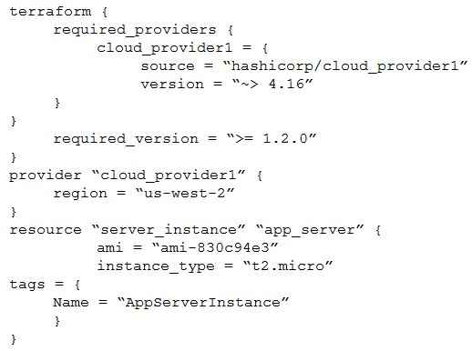
Question #44
(
Topic: Exam A
)
An organization is hosting a seminar with eight individuals who need to connect to their own dedicated VM. The technician used the
following VM configurations:
IP address: DHCP
NIC: 1Gbps
Network: 10.1.10.0/29
Several users are unable to access their VMs. Which of the following best describes the reason?
A. Not enough addresses are available.
B. The routes are misconfigured.
C. Too much traffic is on the network.
D. DHCP is not working correctly on the VM.
Answer:
A
Question #45
(
Topic: Exam A
)
Department supervisors have requested a report that will help them understand the utilization of cloud resources, make decisions about
budgeting for the following year, and reduce costs. Which of the following are the most important requisite steps to create the report?
(
Choose two.
)
A. Set the desired retention of resource logs.
B. Configure application tracing.
C. Integrate email alerts with ticketing software.
D. Enable resource tagging.
E. Configure the collection of performance/utilization logs.
F. Configure metric threshold alerts.
Answer:
DE
Question #46
(
Topic: Exam A
)
A cloud engineer wants to deploy a new application to the cloud and is writing the following script:
Which of the following actions will this script perform?
A. Upload a new VM image.
B. Create a new cloud resource.
C. Build a local server.
D. Import a cloud module.
Answer:
B
Question #47
(
Topic: Exam A
)
A network administrator is building a site-to-site VPN tunnel from the company
’
s headquarters office to the company
’
s public cloud
development network. The network administrator confirms the following:
The VPN tunnel is established on the headquarters office firewall.
While inside the office, developers report that they cannot connect to the development network resources.
While outside the office on a client VPN, developers report that they can connect to the development network resources.
The office and the client VPN have different IP subnet ranges.
The firewall flow logs show that traffic is reaching the development network from the office.
Which of the following is the next step the network administrator should take to troubleshoot the VPN tunnel?
A. Review the development network routing table.
B. Change the ciphers on the site-to-site VPN.
C. Restart the site-to-site VPN tunnel.
D. Check the ACLs on the development workloads.
Answer:
A
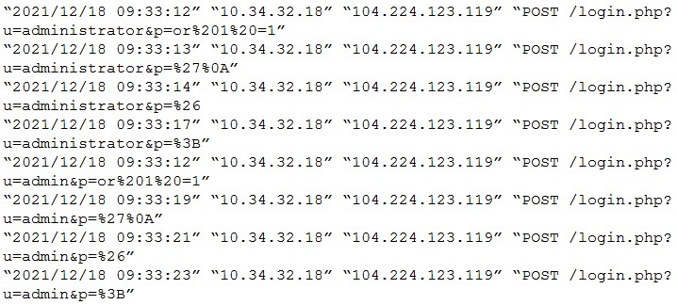
Question #48
(
Topic: Exam A
)
A cross-site request forgery vulnerability exploited a web application that was hosted in a public IaaS network. A security engineer
determined that deploying a WAF in blocking mode at a CDN would prevent the application from being exploited again. However, a
week after implementing the WAF, the application was exploited again. Which of the following should the security engineer do to make
the WAF control effective?
A. Configure the DDoS protection on the CDN.
B. Install endpoint protection software on the VMs.
C. Add an ACL to the VM subnet.
D. Deploy an IDS on the IaaS network.
Answer:
C
Question #49
(
Topic: Exam A
)
An organization
’
s critical data was exfiltrated from a computer system in a cyberattack. A cloud analyst wants to identify the root cause
and is reviewing the following security logs of a software web application:
Which of the following types of attacks occurred?
A. SQL injection
B. Cross-site scripting
C. Reuse of leaked credentials
D. Privilege escalation
Answer:
A
Question #50
(
Topic: Exam A
)
A banking firm
’
s cloud server will be decommissioned after a successful proof of concept using mirrored data. Which of the following is
the best action to take regarding the storage used on the decommissioned server?
A. Keep it temporarily
B. Archive it.
C. Delete it.
D. Retain it permanently.
Answer:
C
Question #51
(
Topic: Exam A
)
A company operates a website that allows customers to upload, share, and retain full ownership of their photographs. Which of the
following could affect image ownership as the website usage expands globally?
A. Sovereignty
B. Data classification
C. Litigation holds
D. Retention
Answer:
A
Question #52
(
Topic: Exam A
)
A systems administrator is provisioning VMs according to the following requirements:
A VM instance needs to be present in at least two data centers.
During replication, the application hosted on the VM tolerates a maximum latency of one second.
When a VM is unavailable, failover must be immediate.
Which of the following replication methods will best meet these requirements?
A. Snapshot
B. Transactional
C. Live
D. Point-in-time
Answer:
C
Question #53
(
Topic: Exam A
)
A DevOps engineer is performing maintenance on the mail servers for a company
’
s web application. Part of this maintenance includes
checking core operating system updates. The servers are currently running version 3.2 of the operating system. The engineer has two
update options
—
one to version 4.1 and the other to version 3.7. Both versions are fully supported by the operating system manufacturer.
Which of the following best describes the action the engineer should take?
A. Upgrade to 3.7 in the development environment.
B. Upgrade to 4.1 on one production server at a time.
C. Read the release notes on version 4.1
D. Schedule a maintenance window and upgrade to 3.7 in the production environment.
Answer:
C
Question #54
(
Topic: Exam A
)
Which of the following is the most cost-effective and efficient strategy when migrating containers to the cloud?
A. Retire
B. Replatform
C. Retain
D. Refactor
Answer:
B
Question #55
(
Topic: Exam A
)
An organization
’
s web application experiences periodic bursts of traffic when a new video is launched. Users are reporting poor
performance in the middle of the month. Which of the following scaling approaches should the organization use to scale based on
forecasted traffic?
A. Scheduled
B. Manual
C. Event
D. Load
Answer:
A
Question #56
(
Topic: Exam A
)
A cloud infrastructure administrator updated the IP tables to block incoming connections and outgoing responses to 104.225.110.203.
Which of the following vulnerability management steps is this an example of?
A. Scanning scope
B. Remediation
C. Identification
D. Assessment
Answer:
B
Question #57
(
Topic: Exam A
)
An administrator needs to adhere to the following requirements when moving a customer
’
s data to the cloud:
The new service must be geographically dispersed.
The customer should have local access to data.
Legacy applications should be accessible.
Which of the following cloud deployment models is most suitable?
A. On-premises
B. Private
C. Hybrid
D. Public
Answer:
C
Question #58
(
Topic: Exam A
)
A company
’
s VMs that are created using the noncritical application tag are automatically shut down at 5:00 p.m. using a cronjob. Which
of the following actions would allow a cloud engineer to stop all unresponsive instances with the least effort in case the automation fails?
A. Using the cloud audit logs for tagging and stopping events
B. Using the cloud provider web console to check and stop the instances
C. Using the cloud provider command line to stop the instances based on tags
D. Using a Bash script to shut down all instances
Answer:
C
Question #59
(
Topic: Exam A
)
A company uses containers stored in Docker Hub to deploy workloads for its IaaS infrastructure. The development team releases changes
to the containers several times per hour.
Which of the following should a cloud engineer do to prevent the proprietary code from being exposed to third parties?
A. Use IaC to deploy the IaaS infrastructure.
B. Convert the containers to VMs.
C. Deploy the containers over SSH.
D. Use private repositories for the containers.
Answer:
D
Question #60
(
Topic: Exam A
)
A social networking company operates globally. Some users from Brazil and Argentina are reporting the following error: website address
was not found. Which of the following is the most likely cause of this issue?
A. Client DNS misconfiguration
B. Regional DNS provider outage
C. DNS server misconfiguration
D. DNSSEC key mismatch
Answer:
B
Question #61
(
Topic: Exam A
)
A junior cloud administrator was recently promoted to cloud administrator and has been added to the cloud administrator group. The
cloud administrator group is the only one that can access the engineering VM. The new administrator unsuccessfully attempts to access
the engineering VM. However, the other administrators can access it without issue. Which of the following is the best way to identify the
root cause?
A. Rebooting the engineering VM
B. Reviewing the administrator
’
s permissions to access the engineering VM
C. Allowing connections from 0.0.0.0/0 to the engineering VM
D. Performing a packet capture on the engineering VM
Answer:
B
Question #62
(
Topic: Exam A
)
Which of the following describes the main difference between public and private container repositories?
A. Private container repository access requires authorization, while public repository access does not require authorization.
B. Private container repositories are hidden by default and containers must be directly referenced, while public container repositories
allow browsing of container images.
C. Private container repositories must use proprietary licenses, while public container repositories must have open-source licenses.
D. Private container repositories are used to obfuscate the content of the Dockerfile, while public container repositories allow for
Dockerfile inspection.
Answer:
A
Question #63
(
Topic: Exam A
)
A DevOps engineer is receiving reports that users can no longer access the company
’
s web application after hardening of a web server.
The users are receiving the following error:
ERR SSL VERSION OR CIPHER MISMATCH.
Which of the following actions should the engineer take to resolve the issue?
A. Restart the web server.
B. Configure TLS 1.2 or newer.
C. Update the web server.
D. Review logs on the WAF.
Answer:
B
Question #64
(
Topic: Exam A
)
A company
’
s engineering department is conducting a month-long test on the scalability of an in-house-developed software that
requires a cluster of 100 or more servers. Which of the following models is the best to use?
A. PaaS
B. SaaS
C. DBaaS
D. IaaS
Answer:
D
Question #65
(
Topic: Exam A
)
A cloud administrator shortens the amount of time a backup runs. An executive in the company requires a guarantee that the backups
can be restored with no data loss. Which of the following backup features should the administrator test for?
A. Encryption
B. Retention
C. Schedule
D. Integrity
Answer:
D
Question #66
(
Topic: Exam A
)
A cloud administrator is building a company-standard VM image, which will be based on a public image. Which of the following should
the administrator implement to secure the image?
A. ACLs
B. Least privilege
C. Hardening
D. Vulnerability scanning
Answer:
C
Question #67
(
Topic: Exam A
)
A cloud deployment uses three different VPCs. The subnets on each VPC need to communicate with the others over private channels.
Which of the following will achieve this objective?
A. Deploying a load balancer to send traffic to the private IP addresses
B. Creating peering connections between all VPCs
C. Adding BGP routes using the VPCs
’
private IP addresses
D. Establishing identical routing tables on all VPCs
Answer:
B
Question #68
(
Topic: Exam A
)
A cloud resource increases its capacity based on seasonal activity. Which of the following best describes this type of cloud instance and
the scaling approach?
A. Fixed; triggered by load
B. Permanent; triggered manually
C. Elastic; triggered by trend
D. Ephemeral; triggered by event
Answer:
C
Question #69
(
Topic: Exam A
)
Which of the following can eliminate the risk of CI/CD pipelines leaking secrets on containers?
A. Peer-reviewed pull requests
B. Use of a VM instead of containers
C. Private image repositories
D. Canary tests
Answer:
C
Question #70
(
Topic: Exam A
)
A company uses containers to implement a web application. The development team completed internal testing of a new feature and is
ready to move the feature to the production environment. Which of the following deployment models would best meet the company
’
s
needs while minimizing cost and targeting a specific subset of its users?
A. Canary
B. Blue-green
C. Rolling
D. In-place
Answer:
A
Question #71
(
Topic: Exam A
)
Once a change has been made to templates, which of the following commands should a cloud architect use next to deploy an IaaS
platform?
A. git pull
B. git fetch
C. git commit
D. git push
Answer:
D
Question #72
(
Topic: Exam A
)
A company is developing a new web application that requires a relational database management system with minimal operational
overhead. Which of the following should the company choose?
A. A database installed on a virtual machine
B. A managed SQL database on the cloud
C. A database migration service
D. A hybrid database setup
Answer:
B
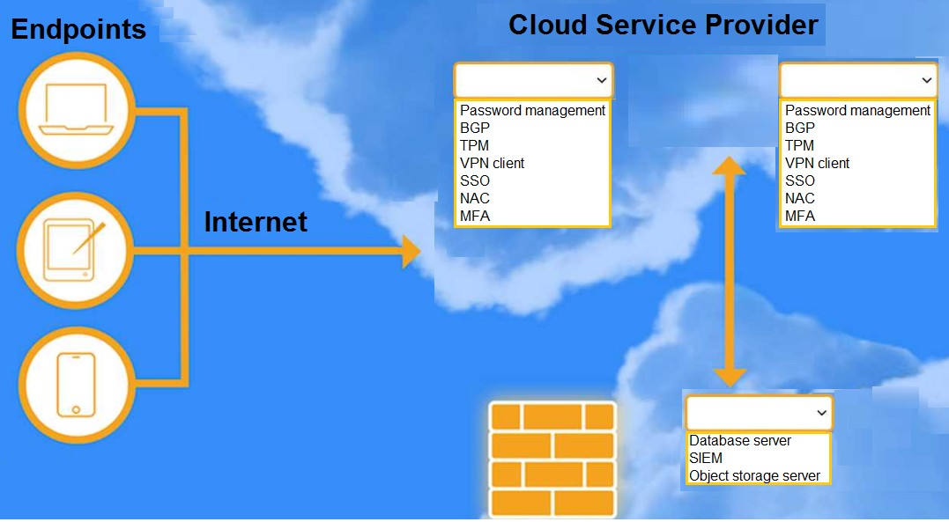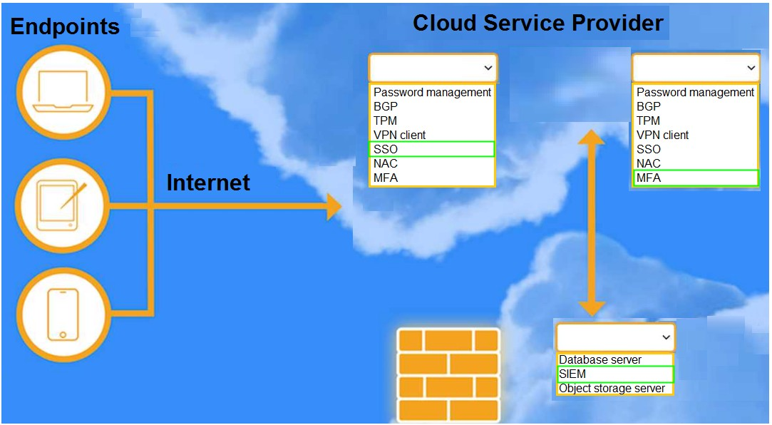
Question #73
(
Topic: Exam A
)
HOTSPOT
A highly regulated business is required to work remotely, and the risk tolerance is very low. You are tasked with providing an identity
solution to the company cloud that includes the following:
secure connectivity that minimizes user login
tracks User activity and monitors for anomalous activity
requires secondary authentication
INSTRUCTIONS
Select controls and servers for the proper control points.
Each control may only be used once.
If at any time you would like to bring back the Initial state of the simulation, please click the Reset All button.
Answer:
Question #74
(
Topic: Exam A
)
SIMULATION
You are a cloud engineer working for a cloud service provider that is responsible for an IaaS offering.
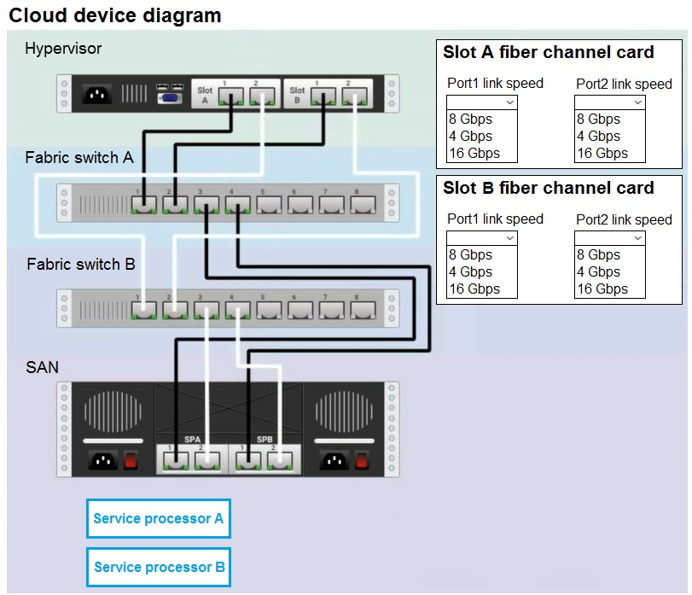
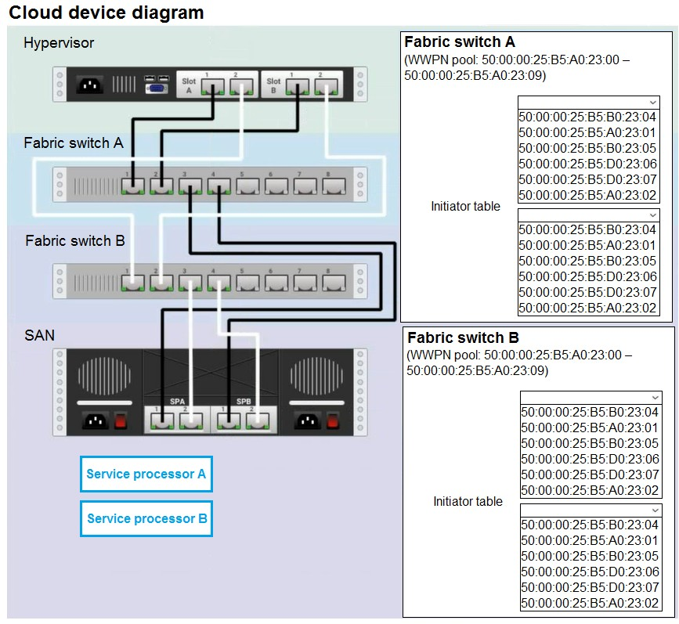
Your customer, who creates VMs and manages virtual storage, has noticed I/O bandwidth issues and low IOPS
(
under 9000
)
.
Your manager wants you to verify the proper storage configuration as dictated by your service level agreement
(
SLA
)
.
The SLA specifies:
Each SFP on the hypervisor host must be set to the maximum link speed allowed by the SAN array.
All SAN array disk groups must be configured in a RAID 5.
The SAN array must be fully configured for redundant fabric paths.
IOPS should not fall below 14000
INSTRUCTIONS
Click on each service processor to review the displayed information. Then click on the drop-down menus to change the settings of each
device as necessary to conform to the SLA requirements.
If at any time you would like to bring back the Initial state of the simulation, please click the Reset All button.
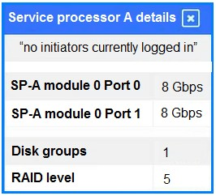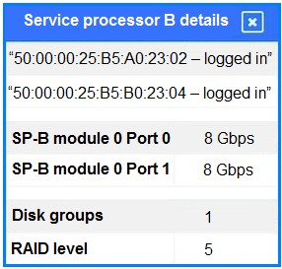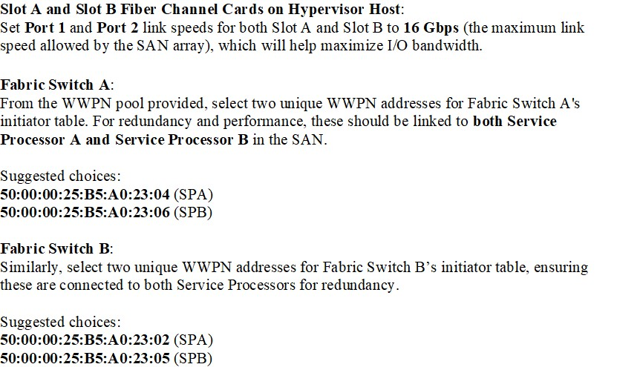
Answer:
Question #75
(
Topic: Exam A
)
Which of the following provides secure, private communication between cloud environments without provisioning additional hardware
or appliances?
A. VPN
B. VPC peering
C. BGP
D. Transit gateway
Answer:
B
Question #76
(
Topic: Exam A
)
A cloud engineer is running a latency-sensitive workload that must be resilient and highly available across multiple regions. Which of the
following concepts best addresses these requirements?
A. Cloning
B. Clustering
C. Hardware passthrough
D. Stand-alone container
Answer:
B
Question #77
(
Topic: Exam A
)
A cloud engineer is in charge of deploying a platform in an IaaS public cloud. The application tracks the state using session cookies and
there are no affinity restrictions. Which of the following will help the engineer reduce monthly expenses and allow the application to
provide the service?
A. Resource metering
B. Reserved resources
C. Dedicated host
D. Pay-as-you-go model
Answer:
D
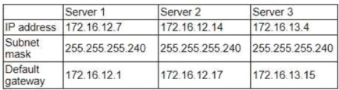
Question #78
(
Topic: Exam A
)
A cloud administrator recently created three servers in the cloud. The goal was to create ACLs so the servers could not communicate with
each other. The servers were configured with the following IP addresses:
After implementing the ACLs, the administrator confirmed that some servers are still able to reach the other servers. Which of the
following should the administrator change to prevent the servers from being on the same network?
A. The IP address of Server 1 to 172.16.12.36
B. The IP address of Server 1 to 172.16.12.2
C. The IP address of Server 2 to 172.16.12.18
D. The IP address of Server 2 to 172.16.14.14
Answer:
C
Question #79
(
Topic: Exam A
)
A company implements a web farm with 100 servers behind an application load balancer. During scaling events, new web servers that are
placed in service have not loaded all their modules, which causes some requests to the web farm to fail. Which of the following should
the cloud engineer implement to address the scaling issue?
A. Instance warm-up
B. Scheduled scaling
C. Event-based scaling
D. Load balancer passthrough
Answer:
A
Question #80
(
Topic: Exam A
)
A CI/CD pipeline is used to deploy VMs to an IaaS environment. Which of the following can be used to harden the operating system once
the VM is running?
A. Docker
B. Kubernetes
C. Git
D. Ansible
Answer:
D
Question #81
(
Topic: Exam A
)
For compliance purposes, a cloud developer at an insurance company needs to save all customer policies for more than ten years. Which
of the following options is the most cost-efficient tier to save the data in the cloud?
A. Archive
B. Hot
C. Cold
D. Warm
Answer:
A
Question #82
(
Topic: Exam A
)
Which of the following do developers use to keep track of changes made during software development projects?
A. Code drifting
B. Code control
C. Code testing
D. Code versioning
Answer:
D
Question #83
(
Topic: Exam A
)
Which of the following strategies requires the development of new code before an application can be successfully migrated to a cloud
provider?
A. Refactor
B. Rearchitect
C. Rehost
D. Replatform
Answer:
A
Question #84
(
Topic: Exam A
)
Which of the following reduces the chance of introducing a misconfiguration into cloud deployment templates?
A. Performing a git fetch after every commit
B. Opening pull requests for changes
C. Using the web interface to update files
D. Committing updates to the main branch
Answer:
B
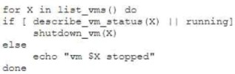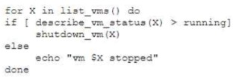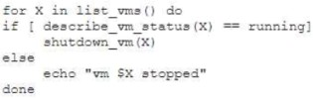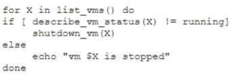
Question #85
(
Topic: Exam A
)
An administrator is creating a cron job that shuts down the virtual machines at night to save on costs. Which of the following is the best
way to achieve this task?
A.
B.
C.
D.
Answer:
C
Question #86
(
Topic: Exam A
)
Which of the following AI/ML technologies consumes text input to discern tone?
A. Text recognition
B. Computer vision
C. Visual recognition
D. Sentiment analysis
Answer:
D
Question #87
(
Topic: Exam A
)
A cloud solutions architect needs to design a solution that will collect a report and upload it to an object storage service every time a
virtual machine is gracefully or non-gracefully stopped. Which of the following will best satisfy this requirement?
A. An event-driven architecture that will send a message when the VM shuts down to a log-collecting function that extracts and
uploads the log directly from the storage volume
B. Creating a webhook that will trigger on VM shutdown API calls and upload the requested files from the volume attached to the
VM into the object-defined storage service
C. An API of the object-defined storage service that will scrape the stopped VM disk and self-upload the required files as objects
D. A script embedded on the stopping VM's OS that will upload the logs on system shutdown
Answer:
A
Question #88
(
Topic: Exam A
)
A cloud architect is preparing environments to develop a new application that will process sensitive data. The project team consists of
one internal developer, two external consultants, and three testers. Which of the following is the most important security control for the
cloud architect to consider implementing?
A. Setting up private development, public development, and testing environments
B. Segregating environments for internal and external teams
C. Configuring DDoS protection to mitigate the risk of downtime
D. Using IAM and ACL in order to bolster DLP
Answer:
D
Question #89
(
Topic: Exam A
)
A cloud engineer wants to implement a monitoring solution to detect cryptojacking and other cryptomining malware on cloud instances.
Which of the following metrics would most likely be used to identify the activity?
A. Disk I/O
B. Network packets
C. Average memory utilization
D. Percent of CPU utilization
Answer:
D
Question #90
(
Topic: Exam A
)
A cloud service provider requires users to migrate to a new type of VM within three months. Which of the following is the best
justification for this requirement?
A. Security flaws need to be patched
B. Updates could affect the current state of the VMs
C. The cloud provider will be performing infrastructure maintenance
D. The equipment is reaching end of life and end of support
Answer:
D
Question #91
(
Topic: Exam A
)
An organization has been using an old version of an Apache Log4j software component in its critical software application. Which of the
following should the organization use to calculate the severity of the risk from using this component?
A. CWE
B. CVSS
C. CWSS
D. CVE
Answer:
B
Question #92
(
Topic: Exam A
)
A company wants to build its new platform using a public cloud. The workload requirements include the following:
•
Implementation of custom CIS compliance
•
Patch for vulnerabilities within 24 hours
•
Warrant at least 1 8001OPS per volume
Which of the following meets the requirements?
A. SaaS
B. IaaS
C. FaaS
D. PaaS
Answer:
B
Question #93
(
Topic: Exam A
)
A cloud security analyst is concerned about security vulnerabilities in publicly available container images. Which of the following is the
most appropriate action for the analyst to recommend?
A. Using CIS-hardened images
B. Using watermarked images
C. Using digitally signed images
D. Using images that have an application firewall
Answer:
A
Question #94
(
Topic: Exam A
)
A critical security patch is required on a network load balancer in a public cloud. The organization has a major sales conference next
week, and the Chief Executive Officer does not want any interruptions during the demonstration of an application behind the load
balancer. Which of the following approaches should the cloud security engineer take?
A. Ask the management team to delay the conference
B. Apply the security patch after the event
C. Ask the upper management team to approve an emergency patch window
D. Apply the security patch immediately before the conference
Answer:
C
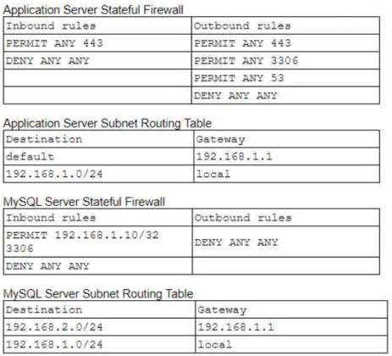
Question #95
(
Topic: Exam A
)
A cloud engineer is troubleshooting a connectivity issue. The application server with IP 192.168.1.10 in one subnet is not connecting to
the MySQL database server with IP 192.168.2.20 in a different subnet. The cloud engineer reviews the following information:
Which of the following should the cloud engineer address to fix the communication issue?
A. The Application Server Stateful Firewall
B. The Application Server Subnet Routing Table
C. The MySQL Server Stateful Firewall
D. The MySQL Server Subnet Routing Table
Answer:
C
Question #96
(
Topic: Exam A
)
A cloud engineer is migrating a company-hosted application to a cloud provider. The data needs to be secure while stored on the third-
party system. Which of the following would best ensure that the data is secure?
(
Choose two.
)
A. Hashing
B. Encoding
C. SAML
D. AES
E. TLS
F. SSL
Answer:
AD
Question #97
(
Topic: Exam A
)
A cloud consultant needs to modernize a legacy application that can no longer address user demand and is expensive to maintain.
Which of the following is the best migration strategy?
A. Retain
B. Rehost
C. Refactor
D. Replatform
Answer:
C
Question #98
(
Topic: Exam A
)
A cloud solution needs to be replaced without interruptions. The replacement process can be completed in phases, but the cost should
be kept as low as possible. Which of the following is the best strategy to implement?
A. Blue-green
B. Rolling
C. In-place
D. Canary
Answer:
B
Question #99
(
Topic: Exam A
)
Which of the following best describes the list of known security vulnerabilities?
A. Common Weaknesses and Enumerations

B. Data Security Standards
C. Zero Trust
D. Common Vulnerabilities and Exposures
Answer:
D
Question #100
(
Topic: Exam A
)
A cloud administrator is working on the deployment of an e-commerce website. The administrator evaluates the scaling methods to be
implemented when seasonal or flash sales are launched. Which of the following scaling approaches should the administrator use to best
manage this scenario?
A. Scheduled
B. Load
C. Event
D. Trending
Answer:
A
Question #101
(
Topic: Exam A
)
Given the following command:
$docker pull images.comptia.org/user1/myimage:latest
Which of the following correctly identifies images.comptia.org?
A. Image registry
B. Image creator
C. Image version
D. Image name
Answer:
A
Question #102
(
Topic: Exam A
)
Which of the following should be considered when using cloud-managed services?
A. Compiling sources
B. Patching the operating system
C. Installing the service
D. Configuring IAM
Answer:
D
Question #103
(
Topic: Exam A
)
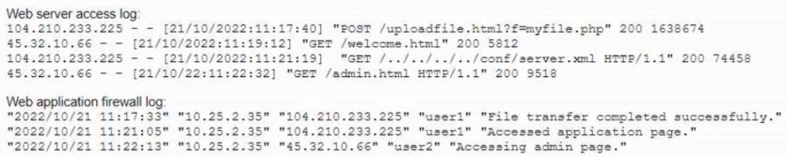
A cloud security analyst is investigating the impact of a recent cyberattack. The analyst is reviewing the following information:
Which of the following has occurred?
A. The corporate administration page was defaced by the attacker
B. A denial-of-service attack was successfully performed on the web server
C. A new user was created on the web server by the attacker
D. Sensitive information from the corporate web server was leaked
Answer:
D
Question #104
(
Topic: Exam A
)
A developer at a small startup company deployed some code for a new feature to its public repository. A few days later a data breach
occurred. A security team investigated the incident and found that the database was hacked. Which of the following is the most likely
cause of this breach?
A. Database core dump
B. Hard-coded credentials
C. Compromised deployment agent
D. Unpatched web servers
Answer:
B
Question #105
(
Topic: Exam A
)
Which of the following best explains the concept of migrating from on premises to the cloud?
A. The configuration of a dedicated pipeline to transfer content to a remote location
B. The creation of virtual instances in an external provider to transfer operations of selected servers into a new, remotely managed
environment
C. The physical transportation installation and configuration of company IT equipment in a cloud services provider
’
s facility
D. The extension of company IT infrastructure to a managed service provider
Answer:
B
Question #106
(
Topic: Exam A
)
A cloud engineer is extending on-premises services to a public cloud. The following design requirements must be considered in the
overall solution:
•
The ability to remotely connect systems from both environments
•
No IP address conflicts or overlap
•
Cost-effectiveness
Which of the following cloud network concepts best meets these requirements?
A. Dedicated connection
B. VPN
C. VLAN
D. ACL
Answer:
B
Question #107
(
Topic: Exam A
)
A cloud engineer wants to replace the current on-premises, unstructured data storage with a solution in the cloud. The new solution
needs to be cost-effective and highly scalable. Which of the following types of storage would be best to use?
A. File
B. Block
C. Object
D. SAN
Answer:
C
Question #108
(
Topic: Exam A
)
A systems administrator is configuring backups on a VM and needs the process to run as quickly as possible, reducing the bandwidth on
the network during all times from Monday through Saturday. In the event of data corruption, the management team expects the mean
time to recovery to be as low as possible. Which of the following backup methods can the administrator use to accomplish these goals?
A. Incremental backup daily to the cloud
B. Full backup on Sunday and incremental backups on all other days of the week
C. Differential backup daily to the cloud
D. Incremental backups during off-hours on Monday, Wednesday, and Friday
Answer:
B
Question #109
(
Topic: Exam A
)
A company has ten cloud engineers working on different manual cloud deployments. In the past, engineers have had difficulty keeping
deployments consistent. Which of the following is the best method to address this issue?
A. Deployment documentation
B. Service logging
C. Configuration as code
D. Change ticketing
Answer:
C
Question #110
(
Topic: Exam A
)
A high-usage cloud resource needs to be monitored in real time on specific events to guarantee its availability. Which of the following
actions should be used to meet this requirement?
A. Configure a ping command to identify when the cloud instance is out of service
B. Create a dashboard with visualizations to filter the status of critical activities
C. Collect all the daily activity from the cloud instance and create a dump file for analysis
D. Schedule an hourly scan of the network to check for the availability of the resource
Answer:
B
Question #111
(
Topic: Exam A
)
A company developed an online trading platform. The engineering team selected event-based scaling for the platform
’
s underlying
resources. The platform resources scale up with every 2,000 subscribed users. The engineering team finds out that although compute
utilization is low scaling is still occurring. Which of the following statements best explains why this is the case?
A. Event-based scaling does not scale down resources
B. Event-based scaling should not be triggered at the 2,000-user frequency
C. Event-based scaling should not track user subscriptions
D. Event-based scaling does not take resource load into account.
Answer:
D
Question #112
(
Topic: Exam A
)
A bank informs an administrator that changes must be made to backups for long-term reporting purposes. Which of the following is the
most important change the administrator should make to satisfy these requirements?
A. Location of the backups
B. Type of the backups
C. Retention of the backups
D. Schedule of the backups
Answer:
C
Question #113
(
Topic: Exam A
)
A security analyst confirms a zero-day vulnerability was exploited by hackers who gained access to confidential customer data and
installed ransomware on the server. Which of the following steps should the security analyst take?
(
Choose two.
)
A. Contact the customers to inform them about the data breach
B. Contact the hackers to negotiate payment to unlock the server
C. Send a global communication to inform all impacted users
D. Inform the management and legal teams about the data breach
E. Delete confidential data used on other servers that might be compromised
F. Modify the firewall rules to block the IP addresses and update the ports
Answer:
DF
Question #114
(
Topic: Exam A
)
A software engineer is integrating an application to the cloud that is web socket based. Which of the following applications is the
engineer most likely deploying?
A. Image-sharing
B. Data visualization
C. Chat
D. File transfer
Answer:
C
Question #115
(
Topic: Exam A
)
Which of the following is the best type of database for storing different types of unstructured data that may change frequently?
A. Vector
B. Relational
C. Non-relational
D. Graph
Answer:
C
Question #116
(
Topic: Exam A
)
A cloud engineer needs to deploy a new version of a web application to 100 servers. In the past, new version deployments have caused
outages. Which of the following deployment types should the cloud engineer implement to prevent the outages from happening this
time?
A. Rolling
B. Blue-green
C. Canary
D. Round-robin
Answer:
B
Question #117
(
Topic: Exam A
)
Which of the following package managers would most likely be used with Ubuntu Linux?
A. YUM

B. DNF
C. Pacman
D. APT
Answer:
D
Question #118
(
Topic: Exam A
)
A cloud engineer hardened the WAF for a company that operates exclusively in North America. The engineer did not make changes to
any ports, and all protected applications have continued to function as expected. Which of the following configuration changes did the
engineer most likely apply?
A. The engineer implemented MFA to access the WAF configurations
B. The engineer blocked all traffic originating outside the region
C. The engineer installed the latest security patches on the WAF
D. The engineer completed an upgrade from TLS version 1.1 to version 1.3.
Answer:
B
Question #119
(
Topic: Exam A
)
Which of the following refers to the idea that data should stay within certain borders or territories?
A. Data classification
B. Data retention
C. Data sovereignty
D. Data ownership
Answer:
C
Question #120
(
Topic: Exam A
)
A cloud server needs to automatically allocate more resources during sudden peak times. This allocation does not need to occur in
regular intervals. Which of the following scaling approaches should be used?
A. Event
B. Manual
C. Trending
D. Scheduled
Answer:
A
Question #121
(
Topic: Exam A
)
Which of the following best describes a system that keeps all different versions of a software separate from each other while giving
access to all of the versions?
A. Code documentation
B. Code control
C. Code repository
D. Code versioning
Answer:
D
Question #122
(
Topic: Exam A
)
Which of the following is an example of refactoring?
A. Creation of a container registry
B. Code changes to facilitate platform hosting
C. Operating system upgrade
D. Document conversion to a secure file format
Answer:
B
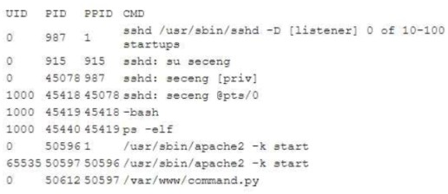
Question #123
(
Topic: Exam A
)
A company recently set up a CDN for its photography and image-sharing website. Which of the following is the most likely reason for the
company's action?
A. To eliminate storage costs
B. To improve site speed
C. To enhance security of static assets
D. To prevent unauthorized access
Answer:
B
Question #124
(
Topic: Exam A
)
The company's IDS has reported an anomaly. The cloud engineer remotely accesses the cloud instance, runs a command, and receives
the following information:
Which of the following is the most likely root cause of this anomaly?
A. Privilege escalation
B. Leaked credentials
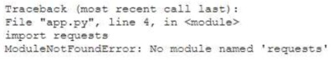
C. Cryptojacking
D. Defaced website
Answer:
A
Question #125
(
Topic: Exam A
)
A developer is building a new application version using a CI/CD pipeline. The developer receives the following error message log when
the build fails.
Which of the following is the most likely cause of this failure?
A. Incorrect version
B. Test case failure
C. Broken build pipeline
D. Dependency issue
Answer:
D
Question #126
(
Topic: Exam A
)
A company wants to implement a work environment that will have low operational overhead and highly accessible enterprise resource
planning, email, and data resources. Which of the following cloud service models should the company implement?
A. IaaS
B. PaaS
C. DBaaS
D. SaaS
Answer:
D
Question #127
(
Topic: Exam A
)
Which of the following industry standards mentions that credit card data must not be exchanged or stored in cleartext?
A. CSA
B. GDPR
C. SOC2
D. PCI-DSS
Answer:
D
Question #128
(
Topic: Exam A
)

A company receives files daily from a bank. The company requires that the files must be copied from the cloud storage resource to
another cloud storage resource for further processing. Which of the following methods requires the least amount of effort to achieve the
task?
A. Remote procedure call
B. SOAP
C. Event-driven architecture
D. REST
Answer:
C
Question #129
(
Topic: Exam A
)
An on-premises data center is located in an earthquake-prone location. The workload consists of real-time, online transaction processing.
Which of the following data protection strategies should be used to back up on-premises data to the cloud while also being cost-
effective?
A. Remote replication for failover
B. A copy that is RAID 1 protected on spinning drives in an on-premises private cloud
C. A full backup to on-site tape libraries in a private cloud
D. Air-gapped protection to provide cyber resiliency
Answer:
A
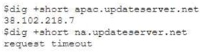
Question #130
(
Topic: Exam A
)
A cloud engineer is deploying a cloud solution that will be used on premises with need-to-know access. Which of the following cloud
deployment models best meets this requirement?
A. Community
B. Public
C. Private
D. Hybrid
Answer:
C
Question #131
(
Topic: Exam A
)
A newly configured VM fails to run application updates despite having internet access. The updates download automatically from a third-
party network. Given the following output:
Which of the following troubleshooting steps would be best to take?
A. Checking DNS configurations
B. Reconfiguring routing protocols
C. Testing the IP address configuration
D. Running a trace to the router
Answer:
A
Question #132
(
Topic: Exam A
)
Which of the following communication methods between on-premises and cloud environments would ensure minimal-to-low latency
and overhead?
A. Site-to-site VPN
B. Peer-to-peer VPN
C. Direct connection
D. VPC peering
Answer:
C
Question #133
(
Topic: Exam A
)
A cloud engineer is collecting web server application logs to troubleshoot intermittent issues. However, the logs are piling up and
causing storage issues. Which of the following log mechanisms should the cloud engineer implement to address this issue?
A. Splicing
B. Rotation
C. Sampling
D. Inspection
Answer:
B
Question #134
(
Topic: Exam A
)
Which of the following cloud native architecture designs is the most easily maintained, decentralized, and decoupled?
A. Monolithic
B. Hybrid cloud
C. Mainframe
D. Microservices
Answer:
D
Question #135
(
Topic: Exam A
)
A cloud security analyst is looking for existing security vulnerabilities on software applications. Which of the following describes this
vulnerability management phase?
A. Analyze
B. Report
C. Remediation
D. Identification
Answer:
D
Question #136
(
Topic: Exam A
)
A new application that will be deployed to cloud VMs has the following requirements:
•
Low inter-VM latency
•
Horizontal scaling support
•
98.5% availability
•
8vCPU and 16GB
•
Ability to split jobs across VMs
Which of the following will best meet these requirements?
A. Load balanced 2vCPU with 4GB RAM on multiregion
B. Load balanced 4vCPU with 8GB RAM on single availability zone
C. Load balanced 2vCPU with 4GB RAM on multiple availability zones
D. Single 8vCPU with 16GB RAM VM on single availability zone
Answer:
C
Question #137
(
Topic: Exam A
)
Which of the following is a customer responsible for in a provider-managed database service?
(
Choose two.
)
A. Operating system patches
B. Table-level permissions
C. Minor database engine updates
D. Cluster configuration
E. Row-level encryption
F. Availability of hardware for scaling
Answer:
BE
Question #138
(
Topic: Exam A
)
A large corporation, which operates exclusively on private cloud environments, is considering a merger and acquisition of two smaller
companies, which operate on premises and in public cloud environments. Which of the following considerations is the most important
for the parent corporation?
A. Data centers, storage, and cost implications
B. Networking, hardware, and computing
C. Platform compatibility and migration strategies
D. Management overhead and vendor lock-in
Answer:
C
Question #139
(
Topic: Exam A
)
A company's data must be recoverable in other regions of the world in the event of a disaster. The data must be available in an RPO of
one hour. Which of the following should a cloud administrator apply to meet these requirements?
A. Replication
B. Retention
C. Encryption
D. Schedule
Answer:
A
Question #140
(
Topic: Exam A
)
A database administrator performs a full backup periodically and keeps several versions in a cloud instance with increasing storage costs.
Which of the following should the administrator consider doing to manage backup retention?
A. Classify backup files based on the sensitivity of data.
B. Set up a time frame for the deletion of old backup files.
C. Identify the need for granular and/or bulk recovery.
D. Determine whether a differential backup will satisfy the operational needs.
Answer:
B
Question #141
(
Topic: Exam A
)
A cloud administrator is provisioning infrastructure to run an application with the following requirements:
•
Ten midsize instances need to run as a cluster most of the day.
•
Sixteen midsize instances are required during peak hours.
•
Costs must be kept low.
•
The instances must be deployed in an IaaS model.
•
The application has no tolerance for service disruptions.
Which of the following steps should the cloud architect take to host the application?
A. Reserve 16 instances but turn off the unused instances outside of peak hours.
B. Use ten pay-as-you-go instances and add six spot instances during peak hours.
C. Deploy reserved instances for normal operation and add pay-as-you-go instances during peak hours.
D. Configure the workload to use spot instances with scheduled scaling for normal operation, including peak hours.

Answer:
C
Question #142
(
Topic: Exam A
)
An IT manager is planning a cloud deployment for a new company. The company does not want on-premises servers or applications.
Which of the following is the best approach for the manager to take?
A. Colocation
—
PaaS
B. Implementation
—
SaaS
C. Migration
—
IaaS
D. Hybrid
—
XaaS
Answer:
B
Question #143
(
Topic: Exam A
)
An on-call cloud engineer receives a critical alert about an e-commerce web server being unresponsive. Which of the following steps
should the engineer take first?
A. Triage
B. Remediation
C. Escalation
D. Monitoring
Answer:
A
Question #144
(
Topic: Exam A
)
Which of the following files should be used to install software with a package manager?
A. package.json
B. package.zip
C. package.deb
D. package.tar
Answer:
C
Question #145
(
Topic: Exam A
)
An application that is running on containers writes files to the operating system after processing data. The produced output files are
stored under /project-files owned by root. A cloud engineer needs to make sure no output files are owned by root. Which of the
following actions should the engineer take to best achieve this objective?
A. Mount the volume in Docker using --user=myapp.
B. Add USER myapp to the Dockerfile and rebuild the container.
C. Run chown myapp:myapp /project-files with cron every minute.
D. Modify the container application to execute sudo -u myapp myapp.
Answer:
B
Question #146
(
Topic: Exam A
)
A cloud engineer is receiving multiple alerts from the infrastructure monitoring agent. The alerts state that all the VMs in the public
subnet are at 100% CPU utilization. However, when the engineer checks the network utilization of the VMs, the network throughput is at
normal levels. Which of the following is the most likely cause of this issue?
A. Ransomware
B. Cryptojacking
C. DDoS
D. Zombie instances
Answer:
B
Question #147
(
Topic: Exam A
)
A cloud engineer is implementing a deployment strategy with the following requirements:
•
At least two environments for production and development must be supported.
•
Changes in one environment must not impact the other environment.
•
The highest possible availability must be achieved.
Which of the following deployment strategies should the engineer implement?
A. Rolling
B. Blue-green
C. In-place
D. Canary
Answer:
B
Question #148
(
Topic: Exam A
)
A cloud solutions architect needs to deploy a simple, public-facing website with the following requirements:
•
Cost-effective
•
Highly available
•
Self-healing
•
Secure
Which of the following will be the most appropriate template to use?
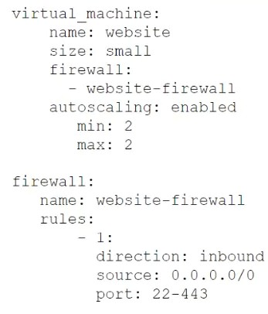
A.
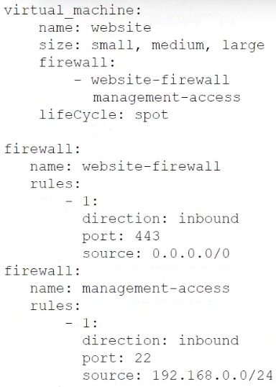
B.

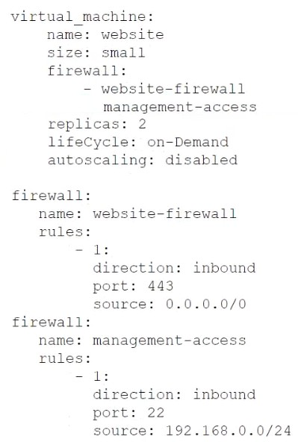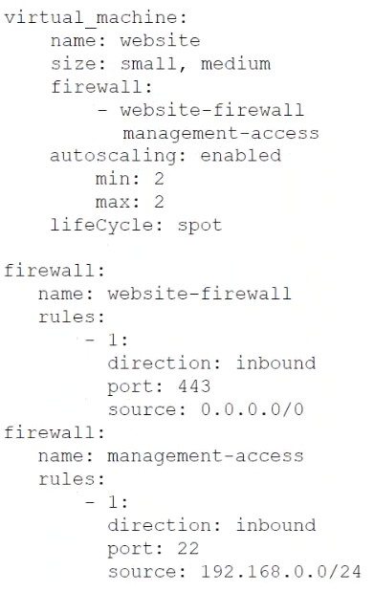
C.
D.
Answer:
D
Question #149
(
Topic: Exam A
)
Which of the following interfaces is most commonly used for SSDs but not for HDDs?
A. NVMe
B. Serial-attached SCSI
C. SATA
D. iSCSI
Answer:
A
Question #150
(
Topic: Exam A
)
Which of the following is the most common characteristic of SSDs?
A. SSDs are less expensive than spinning disks.
B. SSDs have small storage capacities.
C. SSDs can be used for high-IOP applications.
D. SSDs are used mostly in cold storage.
Answer:
C
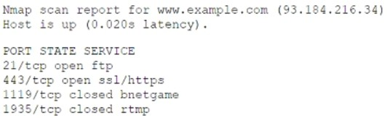
Question #151
(
Topic: Exam A
)
A company experienced a data leak through its website. A security engineer, who is investigating the issue, runs a vulnerability scan
against the website and receives the following output:
Which of the following is the most likely cause of this leak?
A. RTMP port open
B. SQL injection
C. Privilege escalation
D. Insecure protocol
Answer:
D
Question #152
(
Topic: Exam A
)
A cloud developer receives a security vulnerability scan report and needs to analyze and record the true positives. Which of the following
vulnerability management steps is this an example of?
A. Assessment
B. Identification
C. Scanning scope
D. Remediation
Answer:
A
Question #153
(
Topic: Exam A
)
A company recently experienced a ransomware attack. The recovery process was slow because the on-site backups were compromised
and off-site backups were required. Which of the following features would enable a faster recovery if a ransomware attack would happen
again?
A. Integrity
B. Encryption
C. Immutability
D. Replication
Answer:
C
Question #154
(
Topic: Exam A
)
A SaaS provider introduced new software functionality for customers as part of quarterly production enhancements. After an update is
implemented, users cannot locate certain transactions from an inbound integration. During the investigation, the application owner finds
the following error in the logs:
Error: REST API - Deprecated call is no longer supported in this release.
Which of the following is the best action for the application owner to take to resolve the issue?
A. Update the custom integration to use a supported function.
B. Include the custom integration in the quarterly testing scope.
C. Ask the users to monitor the quarterly updates.
D. Revert the application to the last stable quarterly release.
Answer:
A
Question #155
(
Topic: Exam A
)
A developer is building a tool on the cloud that needs to allow other developers to programmatically read and write to the web
application resources. Which of the following should the developer do to meet these requirements with the least complexity?
A. Build a REST API endpoint.
B. Allow access via the cloud portal.
C. Provision cloud-based SQL access.
D. Implement RPC on the web application.
Answer:
A
Question #156
(
Topic: Exam A
)
Users report being unable to access an application that uses TLS 1.1. The users are able to access other applications on the internet.
Which of the following is the most likely reason for this issue?

A. The security team modified user permissions.
B. Changes were made to address vulnerabilities.
C. Privileged access was implemented.
D. The network ACL was modified.
Answer:
B
Question #157
(
Topic: Exam A
)
A customer is migrating applications to the cloud and wants to grant authorization using the classification levels of each system. Which
of the following should the customer implement to ensure authorization to systems is granted when the user and system classification
properties match?
(
Choose two.
)
A. Resource tagging
B. Single sign-on
C. Multifactor authentication
D. Attribute-based access control
E. Token-based authentication
F. Bastion host
Answer:
AD
Question #158
(
Topic: Exam A
)
A vulnerability exists on a critical cloud server. The cloud administrator needs to resolve the issue with minimal interruptions. Which of
the following should the administrator do next?
A. Perform a patch installation during lunchtime.
B. Run a vulnerability scan.
C. Install major updates after business hours.
D. Apply fixes in the testing environment.
Answer:
D
Question #159
(
Topic: Exam A
)
A bank was recently hacked. The bank reviews the logs to see how the attack occurred. The security administrator suspects the logs were
manipulated because no traces of the attack can be found in them. Which of the following should have been enabled before the attack
occurred?
A. Metric and alerts
B. Tracing and aggregation
C. Dashboard and reporting
D. Versioning and immutability
Answer:
D
Question #160
(
Topic: Exam A
)
Which of the following is the best tool to deploy template-based, containerized workloads on premises and on the cloud?
A. Docker
B. Terraform
C. Jenkins
D. Git
Answer:
B
Question #161
(
Topic: Exam A
)
A healthcare provider contacts a MSP about moving an on-premises infrastructure to the cloud. Which of the following requirements are
most important for the MSP to consider when migrating this customer?
(
Choose two.
)
A. Security
B. Cost
C. Availability
D. Storage
E. Compliance
F. Compute
Answer:
AE
Question #162
(
Topic: Exam A
)
A cloud engineer deploys two virtual machines and migrates a local web application and database, respectively. After the engineer
updates the DNS records, the web application does not respond. Which of the following should the cloud engineer do to troubleshoot
the issue?
A. Increase the size and throughput of the virtual machines to allow more concurrent sessions.
B. Verify whether the operating systems in the virtual machines are compatible with the web application and database.
C. Check to ensure the new web application server configuration file points to the correct database location.
D. Repeat the migration to discard any inconsistencies during the data transfer.
Answer:
C
Question #163
(
Topic: Exam A
)
A cloud engineer is provisioning a new application that requires access to the organization
’
s public cloud resources. Which of the
following is the best way for the cloud engineer to authenticate the application?
A. API key
B. Cookie
C. MFA
D. Username and password
Answer:
A
Question #164
(
Topic: Exam A
)
Which of the following protocols is often used in IoT to reduce the amount of data exchanged?
A. MQTT
B. SMB
C. NFS
D. HTTPS
Answer:
A
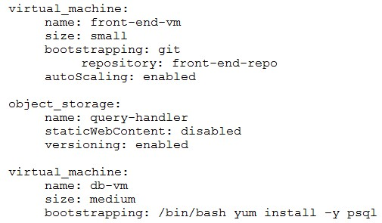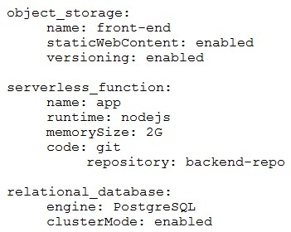
Question #165
(
Topic: Exam A
)
A cloud solutions architect wants to deploy a three-tier web application that requires the minimum amount of operational overhead.
Which of the following is the best template given these requirements?
A.
B.
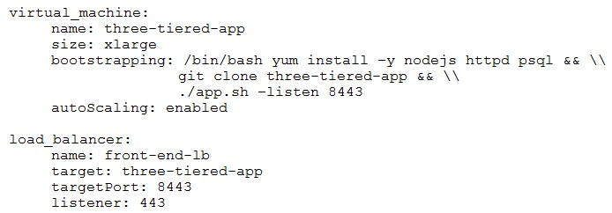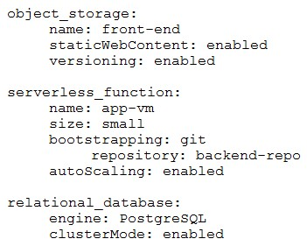
C.
D.
Answer:
B
Question #166
(
Topic: Exam A
)
Which of the following is the correct order of the steps to take when a system is suspected of being vulnerable?
A. Scanning scope, identification, assessment, and remediation
B. Assessment, identification, scanning scope, and remediation
C. Identification, scanning scope, assessment, and remediation
D. Assessment, scanning scope, identification, and remediation
Answer:
A
Question #167
(
Topic: Exam A
)
A software development team would like to test a new feature that was added to the company
’
s production website. The team would
like to allow access to only a small number of users and then, in a controlled way, slowly increase the number of users who have access to
the feature. Which of the following best describes the deployment strategy the software development team should use?
A. In-place
B. Blue-green
C. Canary
D. Rolling
Answer:
C
Question #168
(
Topic: Exam A
)
A cloud developer resigned from an organization and gave a two-week notice. Within the first week since the developer resigned, a
security analyst identifies large volumes of file downloads to the developer
’
s laptop from the source code repository. Which of the
following security controls would be the best way to mitigate the organization
’
s risk of data loss?
A. Implementing a policy to stop cloud developers from sharing passwords
B. Preventing cloud developers from accessing the source code repository
C. Updating outbound firewall rules to block the cloud developer
’
s IP address
D. Blocking internet access for employees that resign from the organization
E. Prohibiting files on the local drive from being transferred to USB drives
Answer:
C
Question #169
(
Topic: Exam A
)
Which of the following facilitates the continuous deployment of cloud applications without performing a clean install on each iteration?
A. Debian package
B. Version management
C. Container image
D. Bare-metal server
Answer:
C
Question #170
(
Topic: Exam A
)
Which of the following container commands implements network port mapping?
A. $docker run
–
it myimage
–
e /bin/port 8080
B. $docker run myimage:port
C. $docker run
–
it
–
p 1-65535 myimage
–
e netstat 8080
D. $docker run
–
it
–
p 80:8080 myimage
Answer:
D
Question #171
(
Topic: Exam A
)
An organization
’
s large e-commerce website requires high availability and cannot have degraded performance. Which of the following
should a cloud administrator do to best meet the requirements?
A. Create a secondary server and load balance the traffic.
B. Upgrade the drives to SSD and change the storage tier.
C. Add a secondary NIC and configure network teaming to the existing server.
D. Change the type of CPU and adjust the RAM size.
Answer:
A
Question #172
(
Topic: Exam A
)
A cloud engineer proposes a solution to migrate a finance application to the cloud. The environment can be shared to reduce costs.
Which of the following models would best meet this requirement?
A. Private
B. Community
C. Public
D. Hybrid
Answer:
B
Question #173
(
Topic: Exam A
)
Which of the following types of storage is read-only and is accessed only when needed?
A. Cold
B. Hot
C. Warm
D. Archive
Answer:
D
Question #174
(
Topic: Exam A
)
A company has solid, validated border protection including a next-generation firewall and IPS. However, compromises and breaches
continue. Which of the following is the best way to improve the company
’
s security controls and reduce the number of incidents?
A. Assess the border protection assets against a CIS benchmark and apply recommendations.
B. Execute a network scan on the border protection and close ports that can be used by attackers.
C. Shift the focus from border protection to a Zero Trust architecture focused on identities.
D. Include a WAF on the network border, increasing protection and adopting security in layers.
Answer:
C
Question #175
(
Topic: Exam A
)
An administrator attempts to use a script to deploy a cloud-based virtual machine with five data disks. After running the script, the
administrator sees the following message:
ERROR: Response 403 storage API provisioning error
Which of the following is the reason the deployment failed?
A. Permission issues
B. Partial outage
C. Functionality deprecation

D. Sizing issues
Answer:
A
Question #176
(
Topic: Exam A
)
A cloud engineer tries to deploy five new cloud instances using code. An error occurs, and the instances are not created. The
configuration fails to run. The engineer then receives the following error message:
ERROR:Parse error on json line x in config
Given the following snippet from the config.json file:
{
"instance_count": 5,
"ssd_options" : ["100GB","200GB","300GB"],
"instance_region": apac,
"instance_code": 255,
"start_instance" : true
}
Which of the following oversights created the error in the configuration file?
A. Incorrect instance_count
B. Incorrect ssd_options
C. Missing quotations on instance_region
D. Missing trailing comma on start_instance
Answer:
C
Question #177
(
Topic: Exam A
)
A company
’
s cybersecurity team receives the following alert that a production VM was deleted from the virtual network:
21
September 09:19:08
(
GMT-5
)
Resource with ID: PROD-WEB001 was deleted by User: Logging
Service
The console to manage virtual network resources uses directory authentication. Only users in a particular directory group can
interactively access the virtual network management console. The logging service account is not part of this group and requires some
local administration privileges to aggregate logs from various resources. The cybersecurity team discovers that the logging service
account was previously given full directory administration privileges and they see the following entry:
21
September 09:10:55
(
GMT-5
)
User with ID: Logging Service was added to the Group: VNet
Console Administrators by actor: Logging Service.
The cybersecurity team removes the compromised service account from the directory group. Which of the following should the
cybersecurity team do next to prevent repeat instances of this issue?
A. Enable two-factor authentication on the virtual network console.
B. Reset the logging service account to use a long and complex password.
C. Disable RDP on the production virtual machines.
D. Create a scoped administrative role for the logging service account.
Answer:
D
Question #178
(
Topic: Exam A
)
A systems engineer tries to mount an iSCSI LUN to a VM host in a data center, but the host does not discover any iSCSI targets. A sample
of the switch configuration is shown in the following image:
GigabitEthernet 1/0/1
description "Development Network Uplink to VM Host A"
access vlan 24
GigabitEthernet 1/0/2
description "Storage Network Uplink to VM Host A"
access vlan 24
spanning-tree portfast
mtu 9216
GigabitEthernet 1/0/3
description "Lights-Out Management VM Host A"
access vlan 20
spanning-tree portfast
GigabitEthernet 1/0/4
description "SAN Management Controller A"
access vlan 20
GigabitEthernet 1/0/5
description "SAN Management Controller B"
access vlan 20
spanning-tree portfast
GigabitEthernet 1/0/6
description "SAN iSCSI Controller A"
access vlan 25
spanning-tree portfast
GigabitEthernet 1/0/7
description "SAN iSCSI Controller B
™
access vlan 25
spanning-tree portfast
Which of the following configuration changes would most likely resolve the discovery issues?
A. Disabling Gigabit Ethernet 1/0/7
B. Changing the MTU on Gigabit Ethernet 1/0/2
C. Changing the access VLAN for Gigabit Ethernet 1/0/2 to 25
D. Enabling jumbo frames on Gigabit Ethernet 1/0/6 and Gigabit Ethernet 1/0/7
Answer:
C
Question #179
(
Topic: Exam A
)
A developer is sending requests to a SaaS application. The developer becomes unable to send anymore requests after sending a number
of them, but other developers can still send requests. Which of the following is most likely causing the issue?
A. Partial outage
B. API throttling
C. Rate limiting
D. Service quota
Answer:
C
Question #180
(
Topic: Exam A
)
Which of the following has the most influence when determining the maximum data loss in the event of a disaster?
A. Recovery point objective
B. Business continuity and disaster recovery
C. Mean time to recover
D. Recovery time objective
Answer:
A
Question #181
(
Topic: Exam A
)
A cloud vendor notifies an administrator that the router version currently in use will no longer be made. Which of the following describes
the stage the router has reached and what needs to be done?
A. The router has reached end of support. The router
’
s software should be updated.
B. The router has reached end of support. The router should be replaced.
C. The router has reached end of life. The router
’
s software should be updated.
D. The router has reached end of life. The router should be replaced.
Answer:
D
Question #182
(
Topic: Exam A
)
Which of the following should be used on containers to process data and keep the output in files for later review?
A. Standard output
B. Optical disk mount
C. Ephemeral storage
D. Persistent volumes
Answer:
D
Question #183
(
Topic: Exam A
)
Users report that in-house developed software has performance issues and behaves in unexpected ways following a recent update. The
developers investigate and find buffer overflows and broken authentications. Which of the following best describes what caused this
issue?
A. Leaked credentials
B. Poor coding practices
C. Cipher suite depreciation
D. Incompatible hardware
Answer:
B
Question #184
(
Topic: Exam A
)
A public cloud environment customer wants to encrypt the data it puts in the cloud. However, the CSP prohibits customer encryption
keys. Which of the following principles is the CSP violating?
A. Data ownership
B. Data sovereignty
C. Data classification
D. Data retention
Answer:
A
Question #185
(
Topic: Exam A
)
Which of the following technologies can read the contents of a printed memo?
A. Document scanning
B. Sentiment analysis
C. Text recognition
D. Natural language processing
Answer:
C
Question #186
(
Topic: Exam A
)
A cloud service provider just launched a new serverless service that is compliant with all security regulations. A company deployed its
code using the service, and the company
’
s application was hacked due to leaked credentials. Which of the following is responsible?
A. Customer
B. Cloud service provider
C. Hacker
D. Code repository
Answer:
A
Question #187
(
Topic: Exam A
)
A cloud engineer is concerned about command-and-control
(
C2
)
communication out of a cloud network over HTTPS. Which of the
following should the cloud engineer implement to most efficiently identify the type of communication?
A. Inline IPS
B. Cloud flow logs
C. Hourly cron listing connections
D. Traffic mirroring
Answer:
B
Question #188
(
Topic: Exam A
)
Two CVEs are discovered on servers in the company
’
s public cloud virtual network. The CVEs are listed as having an attack vector value of
network and CVSS score of 9.0. Which of the following actions is the best way to mitigate the vulnerabilities?
A. Patching the operating systems
B. Upgrading the operating systems to the latest beta
C. Encrypting the operating system disks
D. Disabling unnecessary open ports
Answer:
A
Question #189
(
Topic: Exam A
)
Which of the following cloud services has the highest level of vendor lock-in?
A. Object storage
B. PaaS database
C. Virtual machine
D. File server
Answer:
B
Question #190
(
Topic: Exam A
)
A cloud engineer is developing an operating expense report that will be used to purchase various cloud billing models for virtual
machine instances. The cloud billing model must meet the following requirements:
•
The instance cannot be ephemeral.
•
The minimum life cycle of the instance is expected to be five years.
•
The software license is charged per physical CPU count.
Which of the following best meets these requirements?
A. Dedicated host
B. Spot instance
C. Pay-as-you-go
D. Resource metering
Answer:
A
Question #191
(
Topic: Exam A
)
A system surpasses 75% to 80% of resource consumption. Which of the following scaling approaches is the most appropriate?
A. Trending
B. Manual
C. Load
D. Scheduled
Answer:
C
Question #192
(
Topic: Exam A
)
A cloud administrator is troubleshooting an issue in which clients receive errors when connecting to an application server. The initial
investigation shows the following:
•
The application is behind a load balancer.
•
The load balancer logs show connections being denied.
•
There are no security issues.
•
There are no infrastructure issues on the application servers.
•
All connected clients are working as expected.
Which of the following would most likely cause the issue?
A. The application servers are running low on disk space.
B. The load balancer is unable to connect to the application servers.
C. The application is suffering from a memory leak.
D. The service limit for the load balancer has been met.
Answer:
D
Question #193
(
Topic: Exam A
)
A security engineer recently discovered a vulnerability in the operating system of the company VMs. The operations team reviews the
issue and decides all VMs need to be updated from version 3.4.0 to 3.5.0. Which of the following best describes the type of update that
will be applied?
A. Consistent
B. Patch
C. Minor
D. Ephemeral
Answer:
C
Question #194
(
Topic: Exam A
)
Which of the following costs would increase significantly for data transfer when comparing a multiregion to a single-region cloud
platform design?
A. Storage
B. Power and cooling
C. Network
D. Compliance and regulation
Answer:
C
Question #195
(
Topic: Exam A
)
An organization decides to migrate its software source code framework to microservices. Which of the following correctly describes this
new approach?
A. Public cloud-managed services
B. Tightly coupled architecture
C. Private cloud-managed services
D. Loosely coupled architecture
Answer:
D
Question #196
(
Topic: Exam A
)
An organization is working to become compliant with industry regulations. An administrator needs to amend the organization
’
s existing
log policy so that logs are available during the period in which the organization is audited. Which of the following should the
administrator implement?
A. Log retention
B. Log aggregation
C. Log collection
D. Log tracing
Answer:
A
Question #197
(
Topic: Exam A
)
A company
’
s primary site experiences an outage and must recover as quickly as possible. Which of the following backup or recovery
methods should the company use?
A. In-place
B. Incremental
C. Full
D. Parallel
Answer:
D
Question #198
(
Topic: Exam A
)
Which of the following is a protocol frequently used with IoT devices to communicate with a gateway?
A. ICMP
B. MQTT
C. RPC
D. SSH
Answer:
B
Question #199
(
Topic: Exam A
)
Which of the following is used to quickly deploy applications across different cloud providers?
A. Snapshot
B. Container image
C. Serverless function
D. VM template
Answer:
B
Question #200
(
Topic: Exam A
)
A software development team must manage changes to source code for different clients who utilize the same product with different
features. Which of the following meets this requirement?
A. Branch
B. Commit
C. Push
D. Merge
Answer:
A
Question #201
(
Topic: Exam A
)
Which of the following storage types requires immediate access to backup data in case of a disaster?
A. Archive
B. Hot
C. Cold
D. Warm
Answer:
B
Question #202
(
Topic: Exam A
)
An organization is concerned that its IT help desk is receiving too many calls about password resets for various internal and external
applications. The organization implements a SSO solution. Which of the following technologies should the cloud architect at the
organization recommend implementing?
A. SAML
B. LDAP
C. Kerberos
D. MFA
Answer:
A
Question #203
(
Topic: Exam A
)
A company is running a set of replica containers with image version 1. The company updates the image to version 2 and would like to
replace some of the version 1 images with version 2. During the replacement process, a minimum percentage of version 1 replicas need
to be kept running while starting image version 2 containers alongside them. Which of the following deployment methods is best given
the company
’
s requirements?
A. In-place
B. Rolling
C. Upgrading
D. Patching
Answer:
B
Question #204
(
Topic: Exam A
)
Which of the following is an auditing procedure that ensures service providers securely manage the data to protect the interests of the
organization and the privacy of its clients?
A. CIS
B. ITIL
C. SOC2
D. ISO 27001
Answer:
C
Question #205
(
Topic: Exam A
)
Which of the following commands allows a developer to save changes in the remote repository?
A. git push
B. git fetch
C. git pull
D. git commit
Answer:
A
Question #206
(
Topic: Exam A
)
An independent security researcher discovers a potential vulnerability in a package. The vulnerability could lead to exposure. Which of
the following is the first action the security researcher should take?
A. Uninstall the package to remove the threat.
B. Write a blog post describing how the package vulnerability was discovered.
C. Report the vulnerability to the package vendor
’
s security email.
D. Open a public-facing issue on the vendor
’
s Git repository.
Answer:
C
Question #207
(
Topic: Exam A
)
A cloud administrator needs to provide secure access within the cloud environment to an outsourced development company
’
s users who
conduct business using personal laptops. The administrator needs to protect proprietary data from leaking or being copied on
unauthorized devices. Which of the following mechanisms best fulfills these requirements?
A. VDI
B. API
C. VPN
D. SSH
Answer:
A
Question #208
(
Topic: Exam A
)
A software development team decides to use a code repository. Which of the following is the most likely reason for this decision?
A. Project management
B. Version management
C. Program management
D. Change management
Answer:
B
Question #209
(
Topic: Exam A
)
An organization is preparing for seasonal sales on its storefront web application. Which of the following approaches is best suited to
meet this requirement with the minimal cost?
A. Configuring a load balancer with a least-connections load-balancing method
B. Enabling a scaling configuration for the identified timeline
C. Reconfiguring the application to have more resources
D. Deploying additional compute resources in advance to the web application pool
Answer:
B
Question #210
(
Topic: Exam A
)
Which of the following resources brings content near a geographic location for faster access?
A. Cloud bursting
B. Region
C. Edge computing
D. Availability zone
Answer:
C
Question #211
(
Topic: Exam A
)
An administrator deploys a VM with an additional data disk. A developer installs and configures a database application on the data disk.
After using the VM to perform very intensive read-and-write operations, the developer reports that the VM seems sluggish. Which of the
following solutions represents the least amount of work the administrator needs to do to fix the issue?
A. 1. Create a new VM with more CPU and RAM.
2
. Have the developer install and configure the database application.
B. 1. Stop the VM.
2
. Change the data disk storage type to high performance.
3
. Start the VM.
C. 1. Create a new VM with a high-performance data disk.
2
. Have the developer install and configure the database application.
D. 1. Stop the VM.
2
. Detach the data disk.
3
. Create and attach a new high-performance data disk.
4
. Start the VM.
Answer:
B
Question #212
(
Topic: Exam A
)
Which of the following services is most appropriate for routing requests in front of a replica set of virtual machines that host multiple
websites?
A. Forward proxy
B. Content delivery network
C. Layer 7 load balancer
D. Web application firewall
Answer:
C
Question #213
(
Topic: Exam A
)
Which of the following effects would a modification to the host affinity configuration in the cloud console have?
A. Hosts in a multicloud environment will run on the same host.

B. A VM will run only on a particular underlying host or group of hosts.
C. Host affinity configuration will have no effect in the cloud environment.
D. An affinity rule will not disqualify hosts from being eligible to start.
Answer:
B
Question #214
(
Topic: Exam A
)
Which of the following would a customer most likely be accountable for in a shared responsibility model?
A. Security of data in the data centers
B. Security in the cloud
C. Security of the application
D. Security of the cloud
Answer:
C
Question #215
(
Topic: Exam A
)
A cloud engineer needs to enable monitoring on a virtual machine instance within a cloud service provider. The engineer must monitor
the resources related to the amount of memory an application is utilizing. Which of the following metrics should the engineer monitor
for memory as it relates to disk performance?
A. Heap utilization
B. Swap usage
C. IOPS consumption
D. Queue depth
Answer:
B
Question #216
(
Topic: Exam A
)
An organization and its customer both signed an obligatory agreement that requires both parties to encrypt the data exchanged
between the organization and the customer environment. Which of the following best describes this agreement?
A. Regulatory
B. Litigation
C. Contractual
D. Subscription
Answer:
C
Question #217
(
Topic: Exam A
)
Which of the following should be added to a SAN to decrease the amount of time it takes a server to back up in a private cloud?
A. Fibre Channel
B. Kubernetes
C. Clustering
D. UDP
Answer:
A
Question #218
(
Topic: Exam A
)
An administrator migrates a legacy banking application from a private cloud to a public cloud. Then, the administrator discovers the
application's hardware on the private cloud is no longer compatible for reuse. Which of the following should the administrator do next?
A. Perform a full system backup
B. Apply the latest patches
C. Extend support
D. Decommission the infrastructure
Answer:
D
Question #219
(
Topic: Exam A
)
A user's assigned cloud credentials are locked, and the user is unable to access the project's application. The cloud administrator reviews
the logs and notices several attempts to log in with the user's account were made to a different application after working hours. Which of
the following is the best approach for the administrator to troubleshoot this issue?
A. Create new credentials for the user and restrict access to the authorized application.
B. Track the source of the log-in attempts using the WAF
C. Reset the user's account and implement a stronger lock-out policy
D. Install an IDS on the network to monitor suspicious activity
Answer:
B
Question #220
(
Topic: Exam A
)
A cloud engineer enables API access on a user account for automation on a SaaS-based tool. Which of the following is needed to
authenticate with the REST API?
A. Client ID
B. Password
C. Workstation name
D. Secret key
E. Username
F. Cookie
Answer:
AD
Question #221
(
Topic: Exam A
)
A managed service provider's recent business growth includes customers on different continents. Which of the following should be
considered to prevent issues with regulations?
A. Data sovereignty
B. Data ownership
C. Classification of data
D. Data locality
Answer:
A
Question #222
(
Topic: Exam A
)
A development team is ready to release the latest version of an application. Which of the following strategies best ensures successful
deployment without impacting the bandwidth of company resources?
A. Blue-green
B. A/
В
testing
C. Rolling
D. Shadow
Answer:
C
Question #223
(
Topic: Exam A
)
Unknown attackers targeted a bank
’
s website using HTTP flooding and infiltration via a SQL injection. Which of the following should the
cloud engineer implement as a protection mechanism?
A. DLP
B. IPS
C. Security group
D. WAF
Answer:
D
Question #224
(
Topic: Exam A
)
An engineer receives information about an application issue and reviews the events. The engineer decides to horizontally scale the
application server. Which of the following would most likely explain the engineer's decision?
A. The web server reached the maximum number of TCP sessions.
B. Ephemeral storage for the server OS reached 90%.
C. A runtime error in the application logs indicated a bug in the application.
D. The application server averages 50% CPU and spiked to 90% CPU.
Answer:
A
Question #225
(
Topic: Exam A
)
Which of the following concepts refers to edge computing?
A. Compute resources at a retail store sending data to the cloud
B. Compute resources at a retail store analyzing point-of-sale transactions
C. Compute resources in a public cloud data center analyzing recent sales data
D. Compute resources in an on-premises data center analyzing quarterly sales reports
Answer:
B
Question #226
(
Topic: Exam A
)
Which of the following is the most cost-effective compute service to deploy a service that will be infrequently used but will require fast
response times?
A. Virtual machine
B. Container
C. Serverless
D. Edge
Answer:
C
Question #227
(
Topic: Exam A
)
Which of the following storage types should be used to provide the highest IOPS?
A. Immutable
B. HDD
C. All flash
D. Block
Answer:
C
Question #228
(
Topic: Exam A
)
A cloud engineer is creating a configuration standard to be used on all new cloud deployments. The document should include best
practices designed by industry experts. Which of the following is the optimal way to complete this task?
A. Download the ISO 27001 certification document and certify the company
’
s deployment process.

B. Verify the availability of a CIS benchmark for each in-scope technology
C. Request from the management team a budget to initiate a SOC 2 attestation
D. Invite professionals from the local IT community to contribute to the document
Answer:
B
Question #229
(
Topic: Exam A
)
Which of the following vulnerability management concepts is best defined as the process of discovering vulnerabilities?
A. Scanning
B. Assessment
C. Remediation
D. Prioritization
Answer:
A
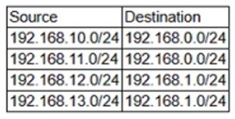
Question #230
(
Topic: Exam A
)
An administrator configures three subnets to the corporate network. All servers should communicate with the main corporate network
and access the internet. The administrator creates the following configurations:
Corporate network: 192.168.0.0/24
Network 2: 192 168.10.0/24
Network 3: 192.168.11.0/24
Network 4: 192.168.12.0/24
After configuring the networks, the administrator recognizes an issue with the configuration. Which of the following can the
administrator change in one step to accomplish the goal?
A. Remove source 192.168.12.0/24 and destination 192.168.1.0/24 from the routing table
B. Replace destination 192.168.1.0/24 with destination 192.168.0.0/24
C. Add source 192.168.12.0/24 and destination 192 168 0.0/24 to the routing table
D. Reconfigure Network 4 to 192.168.13.0/24
Answer:
B
Question #231
(
Topic: Exam A
)
A cloud engineer is selecting a model for a data center that will host a workload. The database must reside within the data center on the
company's SAN solution. However, the workload will be hosted by a third-party vendor. Which of the following models should the cloud
engineer select to meet these requirements?
A. Community
B. Hybrid
C. Public
D. Private
Answer:
B
Question #232
(
Topic: Exam A
)
A new major version of a package installed on a VM was recently released. Which of the following should a cloud engineer do first before
applying the upgrade?
A. Review for package dependencies
B. Raise a change request
C. Investigate for any breaking changes
D. Verify that patching the VM will not reset user data
Answer:
C
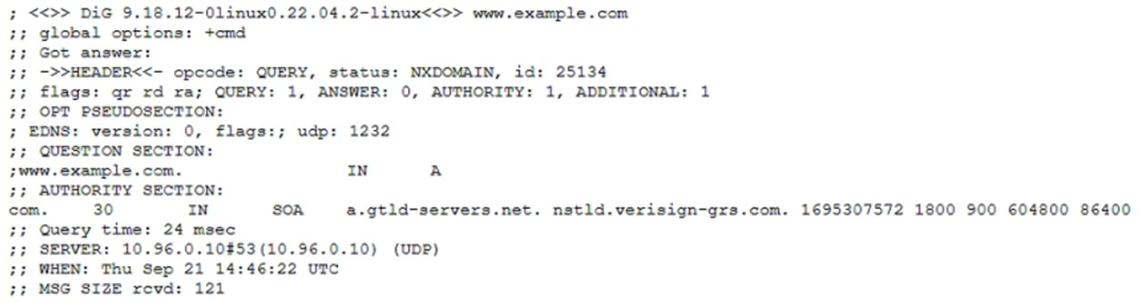
Question #233
(
Topic: Exam A
)
A cloud engineer needs to choose a storage technology that fulfills the following requirements:
•
99.99% durability
•
Resilient to instance failures
•
Resilient to instance deletions
Which of the following types of storage is the best option?
A. Ephemeral
B. Cache
C. Persistent
D. Local
Answer:
C
Question #234
(
Topic: Exam A
)
A cloud engineering team recently built a new website to be hosted on a cloud server. However, the website is not loading. The team
runs a troubleshooting command that provides the following output:
Which of the following records would the team most likely add to resolve this issue?
A. MX
B. A
C. PTR
D. SRV
Answer:
B
Question #235
(
Topic: Exam A
)
After receiving multiple complaints that an application is not always available, a cloud engineer reviews the application's performance.
According to monitoring data the application receives different volumes of traffic at unpredictable times, which impacts performance.
Which of the following is the best scaling strategy to improve the application's performance?
A. Scheduled
B. Vertical
C. Manual
D. Horizontal
Answer:
D
Question #236
(
Topic: Exam A
)
A company has been using a CRM application that was developed in-house and is hosted on local servers. Due to internal changes, the
company wants to migrate the application to the cloud without having to manage the infrastructure. Which of the following services
should the company consider?
A. SaaS
B. PaaS
C. XaaS
D. IaaS
Answer:
B
Question #237
(
Topic: Exam A
)
At the beginning of every month, new marketing materials are uploaded to the cloud server for sales employees to use. At the same
time, other users report that their access is sluggish, and the system is almost unusable. Which of the following scaling approaches
should be applied to remedy this issue?
A. Scheduled
B. Load
C. Event
D. Managed
Answer:
A
Question #238
(
Topic: Exam A
)

A cloud administrator needs to distribute workloads across remote data centers for redundancy reasons Which of the following
deployment strategies eliminates downtime accelerates deployment, and deploys in batches?
A. In-place
B. Rolling
C. Blue-green
D. Canary
Answer:
B
Question #239
(
Topic: Exam A
)
A cloud engineer must improve the availability of a database for an application. The database must meet the following requirements:
•
Failover capability in case of a data center outage
•
Point-in-time data restoration capabilities
Which of the following best meets these requirements?
A. Clustered database instance
B. Cached Redis cluster
C. Database instance replica
D. Multi-availability zone database instance
Answer:
D
Question #240
(
Topic: Exam A
)
A cloud administrator is implementing backups for a virtual file server with a large number of daily changes to files. The backups have
historically caused performance issues on the server. As a result, the company has asked for backups to be completed as quickly as
possible. The administrator opts for an incremental backup technology. Which of the following statements best explains the
administrator's choice?
A. Differential backups cannot be used in conjunction with full backups
B. Differential backups are generally slower than incremental backups
C. Differential backups cannot be used for granular recovery.
D. Differential backups always consume more space than incremental backups
Answer:
B
Question #241
(
Topic: Exam A
)
A cloud engineer is managing a three-tiered application. An application load balancer is sitting in front of a web layer. After a
deployment, the engineer tries to access the website and receives an HTTP 504 error. Which of the following should the engineer do to
identify the issue?
A. Restart the database
B. View the health check configuration
C. Update the autoscaling policy
D. Redeploy the application tiers in a new subnet
Answer:
B
Question #242
(
Topic: Exam A
)
Which of the following does an engineer need in order to calculate the number of IOPS required in a storage resource?
A. Network capacity
B. Block size
C. Memory utilization
D. Latency
Answer:
D
Question #243
(
Topic: Exam A
)
Which of the following is a benefit of using containerization in DevOps environments?
A. Containerization improves security control by sharing resources among containers
B. Containerization provides the use of a proprietary technology that improves integrity
C. Containerization facilitates performance monitoring over VMs
D. Containerization allows the creation of applications with interconnected components
Answer:
D
Question #244
(
Topic: Exam A
)
A systems engineer is migrating a batch of 25 VMs from an on-premises compute cluster to a public cloud using the public cloud
’
s
migration agent. The migration job shows data copies at a rate of 250Mbps. After five servers migrated, the remaining data copied at a
rate of 25Mbps. Which of the following is the most likely cause of the issue?
A. The local VM host hardware utilization
B. The ISP throttling rate
C. The IOPS on the SAN backing the on-premises cluster
D. The compute utilization of the VMs being migrated
Answer:
C
Question #245
(
Topic: Exam A
)
A developer is deploying a new version of a containerized application The DevOps team wants:
•
No disruption
•
No performance degradation
•
Cost-effective deployment
•
Minimal deployment time
Which of the following is the best deployment strategy given the requirements?
A. Canary
B. In-place
C. Blue-green
D. Rolling
Answer:
D
Question #246
(
Topic: Exam A
)
Which of the following types of releases best describes the update made to a code repository production release when it changes from
version 1.0 to version 1.1?
A. Alpha
B. Beta
C. Minor
D. Major
Answer:
C
Question #247
(
Topic: Exam A
)
A cloud engineer discovers that two nodes experience resource exhaustion during the holidays. This creates a denial of service on the
web application. Adding a third node is not an option because of budgetary constraints. Which of the following scaling approaches helps
minimize resource exhaustion?
A. Event trigger
B. Load trigger
C. Vertical scaling
D. Horizontal scaling
Answer:
C
Question #248
(
Topic: Exam A
)
Which of the following allows network access to services deployed in a container?
A. Forward proxy
B. Network orchestration
C. Host affinity
D. Port mapping
Answer:
D
Question #249
(
Topic: Exam A
)
A cloud administrator must increase the performance of an application by modifying the server disks from HDD to SSD. In which of the
following ways will the server most benefit from this change?
A. Smaller storage footprint
B. Increase in IOPS
C. More memory throughput
D. Fewer CPU cycles
Answer:
B
Question #250
(
Topic: Exam A
)
A cloud engineer is migrating a website to the cloud. The website was developed with a legacy programming language framework and
must be upgraded to a newer version to remediate code vulnerabilities and improve performance. Which of the following is the best
strategy to perform the migration?
A. Refactor
B. Rehost
C. Replatform
D. Re-architect
Answer:
A
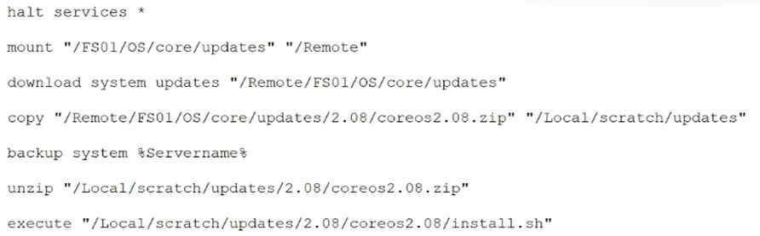
Question #251
(
Topic: Exam A
)
A certain user subset is seeing the error message 500 Internal Server Error on a newly launched distributed web application. The
developers are unable to troubleshoot this issue because of limited visibility into the application's operations. Which of the following
should the developers do first to effectively troubleshoot the issue?
A. Modify the application code to display proper log files.
B. Generate graphs and dashboards that show the rate of error.
C. Implement incident response management.
D. Provision log aggregation software.
Answer:
D
Question #252
(
Topic: Exam A
)
A systems administrator reviews the following standard maintenance script:
The script is difficult for the systems administrator to update because the location and the name of the update binary are referenced in
the copy command. The script execution triggers future line changes each time maintenance is performed. Which of the following will
resolve this issue with minimal overhead?
A. Implementing an API to receive the parameters remotely
B. Adding a variable to contain the file path
C. Creating a function to search the remote filesystem
D. Inserting a line into the code that calls to a different script
Answer:
B
Question #253
(
Topic: Exam A
)
Which of the following is the most appropriate service to publish an application that requires very low latency connections?
A. Virtual private cloud
B. Network load balancer
C. Application gateway
D. Application load balancer
Answer:
B
Question #254
(
Topic: Exam A
)
An engineer is deploying a new application with the following requirements:
•
Uses automation
•
Deploys some components
•
Does not deploy the virtual machines
Which of the following are reasons that the deployment may only partially fail?
(
Choose two.
)
A. Service quotas cannot be exceeded.
B. The credentials for the deployment are incorrect.
C. The cloud provider
’
s API is not working.
D. The version of the infrastructure code is outdated.
E. The cloud provider has a full outage.
F. The permissions are insufficient.
Answer:
BF
Question #255
(
Topic: Exam A
)
A company wants to avoid vendor lock-in situations. Which of the following options should the company consider before doing business
with a vendor?
(
Choose two.
)
A. Cost factor
B. Open-source technologies
C. Data portability
D. Regulatory compliance
E. Service availability
F. Storage options
Answer:
BC
Question #256
(
Topic: Exam A
)
A media company is dealing with a large influx of live stream traffic. A cloud engineer notices the following on a VM:
•
Network usage metric is at 100%.
•
CPU is under 65% utilization.
•
Memory utilization is at 50%.
•
Response time to the website is increasing.
Which of the following is the best solution to address these issues?
A. Increasing the storage capacity
B. Increasing the virtual machine size
C. Adding an additional network card
D. Adding a load balancer
Answer:
D
Question #257
(
Topic: Exam A
)
A cloud engineer is applying a critical security patch to multiple servers that have an SSH vulnerability. Which of the following is the
fastest way to patch the servers and uses the fewest compute resources?
A. Log in to each server simultaneously and apply the patch, then restart the servers.
B. Update configuration management scripts to include the patch, then apply the configuration to a primary list of servers.
C. Clone the servers using a readily available cloning tool, apply the patch to the new servers, and delete the old ones.
D. Launch new servers from a patched image, install server configurations, and shut down the old servers.
Answer:
B
Question #258
(
Topic: Exam A
)
Which of the following can connect multiple VPCs and an on-premises network?
A. Subnet
B. CDN
C. Peering

D. Transit gateway
Answer:
D
Question #259
(
Topic: Exam A
)
A cloud application fails to retrieve data from an API. A cloud engineer reviews the following log:
[
ERROR] HTTP 429 - Too many requests
[
INFO] API rate limit exceeded
[
WARNING] API throttled
Which of the following is the best resolution?
A. Upgrade the network bandwidth
B. Increase the database storage.
C. Implement exponential backoff.
D. Restart the API server.
Answer:
C
Question #260
(
Topic: Exam A
)
Which of the following has a mandatory
tag in the exchange of data between two systems?
A. JSON
B. SOAP
C. JWT
D. REST
Answer:
B
Question #261
(
Topic: Exam A
)
Which of the following compute services is the best for quick and easy provisioning?
A. Cluster
B. Container
C. Server less
D. Snapshot
Answer:
C
Question #262
(
Topic: Exam A
)
A cloud engineer is designing a solution that requires end users:
•
To be authenticated
•
To be authorized
•
To be in approved locations.
•
To use only corporate devices
Which of the following is the best way to meet these requirements?
A. Secure by design
B. Principle of least privilege
C. Zero Trust
D. Defense in depth
Answer:
C
Question #263
(
Topic: Exam A
)
Which of the following storage types should be used by a data lake implemented on a CSP?
A. Object
B. Block
C. File
D. Ephemeral
Answer:
A
Question #264
(
Topic: Exam A
)
Which of the following best explains RPO?
A. The time needed to recover from a disaster
B. The acceptable amount of data loss after a disaster
C. The estimated amount of data loss after a disaster
D. The time estimated between disasters
Answer:
B
Question #265
(
Topic: Exam A
)
A security analyst receives the following security alert:
The following VM
(
vm_1
)
is exhibiting signs increased CPU usage over a 24-hour period. Please consider increasing the allocated CPU
cores.
After additional investigation, the analyst identifies a process consuming 98% CPU utilization on the VM. The analyst attempts to stop
the process, but the process continues. Which of the following is the most likely cause of this security alert?
A. Hashing
B. Cryptojacking
C. Phishing
D. On-path attack
Answer:
B
Question #266
(
Topic: Exam A
)
A cloud engineer logs in to Grafana. Which of the following actions is the engineer most likely trying to accomplish?
A. Deploying a new version of an application
B. Observing an application's health
C. Putting an application into a container
D. Pushing new code to the Git source
Answer:
B
Question #267
(
Topic: Exam A
)
Which of the following requirements are the most important when provisioning cloud resources for a client in the finance industry?
(
Choose two.
)
A. Cost
B. Security
C. Compute
D. Network
E. Storage
F. Compliance
G. Performance
Answer:
BF
Question #268
(
Topic: Exam A
)
A cloud architect is evaluating a cloud migration strategy for a CRM application. The CRM application's most important requirement is
application portability. Which of the following factors is most important for the cloud architect to consider?
A. Management overhead
B. Vendor lock-in
C. Platform compatibility
D. Service availability
Answer:
B
Question #269
(
Topic: Exam A
)
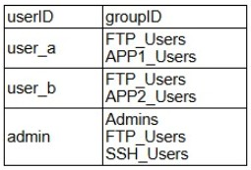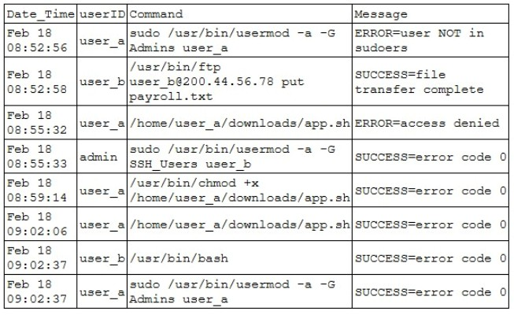
A cloud engineer creates a new private subnet within a VPC that contains existing subnets. The new subnet is unreachable from the other
subnets. The existing subnets can reach each other. Which of the following best describes the cause of this issue?
A. DNS issues
B. WAF blocking
C. Incorrect IP address
D. Missing route
Answer:
D
Question #270
(
Topic: Exam A
)
During an incident, a cloud security engineer finds that a suspicious file was run in a virtual desktop. The cloud security engineer obtains
a list of users involved in the incident:
The cloud security engineer also obtains the system logs:
Which of the following types of vulnerabilities did the malicious application most likely exploit?
A. Privilege escalation
B. Improper permissions
C. Data exfiltration
D. Leaked credentials
Answer:
A
Question #271
(
Topic: Exam A
)
A company has its application in a Docker container running in a single node in a cloud environment. The company is growing, and
multiple customers now require the addition of more containers to accommodate the increasing load. New nodes will be deployed to
manage the additional containers. Which of the following is the best approach to manage the new environment?

A. Create a Jenkins pipeline to execute the Docker containers in the nodes farm.
B. Configure Terraform to start the Docker containers by using customized user data on the new worker nodes
C. Utilize Ansible to deploy the new containers into the new worker nodes
D. Use Kubernetes to orchestrate containers allocation throughout multiple worker nodes
Answer:
D
Question #272
(
Topic: Exam A
)
A company is required to save historical data for seven years. A cloud administrator implements a script that automatically deletes data
older than seven years. Which of the following concepts best describes why the historical data is being deleted?
A. End of life
B. Data loss prevention
C. Cost implications
D. Tiered storage for archiving
Answer:
A
Question #273
(
Topic: Exam A
)
A cloud-based application needs to connect to a legacy, on-premises application but fails to create a secure connection. Which of the
following is the most likely reason that the application cannot connect?
A. The cloud application is throttling the API
B. The cloud application is changing the DNS during connection
C. The on-premises application cannot communicate to the NAT
D. The on-premises application is using depreciated ciphers
Answer:
D
Question #274
(
Topic: Exam A
)
A workload runs in an IaaS public cloud environment. An engineering team must secure access to the VMs for managing the services.
The VMs currently expose the SSH service to the internet. Which of the following solutions reduces the risk of hacking with the least
maintenance?
A. Deploying MFA for the SSH connections
B. Adding a managed IaaS instance and using it as bastion host to access the VMs
C. Blocking SSH with a network ACL and using private endpoints for management
D. Replacing SSH with RDP
Answer:
B
Question #275
(
Topic: Exam A
)
A cloud engineer needs to upgrade the pip python module by running the following command:
python.exe -m pip install -upgrade pip
However, after the command is entered, the engineer receives the following error message:
WARNINg: Retrying
(
Retry
(
TOTAL=4 connect=None, read=None, redirect=None, status=None
)
after connection broken by
'SSLError
(
SSLCertVerificationError
(
, [SSL: /packages/07/51/abasciekdkgiyiykrieeeotlriturjaab/pip-27.4.3.py3-none-any.whl
1
Given this scenario, which of the following is more than likely the cause of the issue?
A. Syntax error with the command entered
B. Python version incompatibility
C. Broken TLS communication with no internet access
D. Certificate for package repository is not trusted
Answer:
D
Question #276
(
Topic: Exam A
)
A cloud developer addresses a bug in one of the company
’
s applications. The developer wants to record the changes and retain the
application history. Which of the following steps should the developer take?
A. Code commit
B. Code refactor
C. Code review
D. Code request
Answer:
A
Question #277
(
Topic: Exam A
)
Which of the following is the most restrictive data classification label?
A. Proprietary
B. Private
C. Sensitive
D. Confidential
Answer:
D
Question #278
(
Topic: Exam A
)
Several fitness centers in an area are collectively looking for a cost-effective way to migrate their servers to the cloud. Which of the
following is the best cloud deployment model to meet these needs?
A. Hybrid
B. Public
C. Community
D. Private
Answer:
C
Question #279
(
Topic: Exam A
)
A company is building a loosely coupled application. The engineering team discovers issues with how the application is handling events.
Which of the following should the team implement to resolve this issue?
A. Host affinity
B. Monolithic services
C. Fan-out architecture
D. ELK stack
Answer:
C
Question #280
(
Topic: Exam A
)
A cloud-based VM is no longer required. However, the sensitive data on the VM's data disk must be retained. Which of the following is
the best approach for the administrator to take?
A. 1. Delete the VM and disks.
2
. Retain the VM's backups.
B. 1. Take a snapshot of the data disk.
2
. Delete the VM and disks.
C. 1. Stop the VM.
2
Tag the VM.
D. 1. Delete the source VM and disks.
2
. Copy the data to another VM.
Answer:
B
Question #281
(
Topic: Exam A
)
A network engineer wants to implement a service that has the following characteristics:
•
Highly flexible
•
Centralized
•
Programmatic
•
Dynamically adjustable to traffic
Which of the following is the best approach?
A. Software-defined network
B. Virtual private network
C. Content delivery network
D. Network load balancer
Answer:
A
Question #282
(
Topic: Exam A
)
A user reports that a cloud application has been behaving erratically over the last month. Which of the following should a cloud engineer
use to get a clear understanding of the situation?
A. System alerts
B. Intrusion prevention system
C. Network logs
D. Performance metrics
Answer:
D
Question #283
(
Topic: Exam A
)
Which of the following best explains the use of CDN?
A. To control traffic to and from the cloud environment and prevent unauthorized connections
B. To protect the perimeter of on-premises and cloud networks through segmentation
C. To create a secure communication channel to protect traffic between two geographically distant sites
D. To allow access to content through the geographic distribution and replication of data
Answer:
D
Question #284
(
Topic: Exam A
)
A small nonprofit wants a cheap and simple way to automate some of its workflows that connect different services together in the cloud.
Which of the following options best fulfills this need?
A. Using a managed service provider
B. Leveraging an integration platform as a service
C. Automating workflows with Python and deploying in a VM
D. Implementing a message broker to access the APIs
Answer:
B
Question #285
(
Topic: Exam A
)
A DevOps engineer is performing maintenance on the mail servers for a company's web application. Part of this maintenance includes
checking core operating system updates. The servers are currently running version 3.2 of the operating system. The engineer has two
update options
—
one to version 4.1 and the other to version 3.7 Both versions are fully supported by the operating system manufacturer.
Which of the following best describes the action the engineer should take?
A. Upgrade to 3.7 in the development environment.
B. Upgrade to 4.1 on one production server at a time.
C. Upgrade only one production server to 4.1.
D. Schedule a maintenance window and upgrade to 3.7 in the production environment.
Answer:
A
Question #286
(
Topic: Exam A
)
A cloud engineer is updating a company's Git system that is currently hosted on version 7.1 of a VM. To avoid potential breaking
changes, only the latest minor updates are allowed. Which of the following versions should the engineer update the Git system to?
A. 6.5
B. 7.6
C. 7.9
D. 8.1
Answer:
C
Question #287
(
Topic: Exam A
)
An organization hosts its own data center. It has recently migrated some of its applications to the cloud, but some applications remain in
its data center. Which of the following best describes the organization
’
s cloud deployment model?
A. Community
B. Private
C. Hybrid
D. Public
Answer:
C
Question #288
(
Topic: Exam A
)
A workload that is running in the cloud has a stable resource consumption without major variations. After applying an application
update, RAM utilization increases by 20%. The application can be stopped with no business impact, and utilization is expected to remain
constant for the next two months. Which of the following is a way to adjust the resources for the application with the least amount of
effort?
A. Add a trend to trigger vertical scaling
B. Manually adjust the compute size
C. Set up a load trigger to modify resources
D. Develop an IaC script to adjust computing attributes
Answer:
B
Question #289
(
Topic: Exam A
)
A cloud engineer must scan cloud resources for vulnerabilities. Which of the following is the first step the cloud engineer should take?

A. Remediate the vulnerabilities
B. Assess the systems.
C. Define the scope
D. Research the CVEs
Answer:
C
Question #290
(
Topic: Exam A
)
A cloud engineer deploys a group of new VMs to the cloud environment. The VMs have access to sensitive data. Which of the following
data protection methods should the engineer use to protect this data from ransomware?
A. Volume encryption
B. Immutable storage
C. Incremental backups
D. Data replication
Answer:
B
Question #291
(
Topic: Exam A
)
A DevOps engineer is initiating a build on a CI/CD pipeline by committing changes to a private repository. Which of the following is the
purpose of the private repository?
A. To protect code assets
B. To deploy to production
C. To implement version control
D. To perform integration testing
Answer:
A
Question #292
(
Topic: Exam A
)
A cloud developer is developing a cloud-native application with the following requirements:
•
Must be a web-based application
•
Must be as cost-effective as possible
•
Must have fast response times
•
Must be scalable to meet demand
Which of the following technologies will best meet these requirements?
A. Serverless function
B. VM
C. CDN
D. API gateway
Answer:
A
Question #293
(
Topic: Exam A
)
Which of the following best describes a compute resource that has its own networking system, OS, CPU, and RAM running on physical
hardware?
A. Clustering
B. Virtual machine
C. Container
D. Stand-alone
Answer:
D
Question #294
(
Topic: Exam A
)
Which of the following commands allows a cloud engineer to create a new template on the local system to later send for code review?
A. git checkout -b newfeature
B. git fetch newfeature
C. git pull newfeature
D. git commit -m "newfeature"
Answer:
A
Question #295
(
Topic: Exam A
)
An organization uses a cloud provider's specific features to host applications. The organization planned to move to another cloud
provider due to rising costs, but moving was not technically feasible. Which of the following best describes this situation?
A. Platform as a service
B. Oversubscription
C. Vendor lock-in
D. Regulatory compliance
Answer:
C
Question #296
(
Topic: Exam A
)
A cloud engineer must configure a backup at the end of the month. Given the following requirements:
•
Minimal backup size
•
Faster backup speed
Which of the following backup types best meets the requirements?
A. Tape
B. Full
C. Differential
D. Incremental
Answer:
D
Question #297
(
Topic: Exam A
)
A company wants to build a database that will receive requests from its application, but it also has a lot of customer data that must be
archived. Which of the following solutions takes into consideration performance and cost implications?
A. SSD for the customer data, SSD for the database
B. SSD for the database, HDD for the customer data
C. Object storage for the database, SSD for the customer data
D. Object storage for the customer data, HDD for the database
Answer:
B
Question #298
(
Topic: Exam A
)
A company notices inconsistencies in its cloud environment. After further analysis, the company discovers that some developers have
been making manual configuration changes that roll back changes made by the DevOps team. Which of the following should the
company do to best manage its cloud infrastructure?
(
Choose two.
)
A. Enable versioning on cloud resources in order to easily roll back changes
B. Use cloud policies to enforce the company
’
s standards
C. Restrict access to the cloud console to only the DevOps team
D. Create scripts that use the cloud provider
’
s CLI
E. Use IaC to handle the company's cloud resources
F. Deploy the applications using containers
Answer:
BE
Question #299
(
Topic: Exam A
)
A cloud security engineer discovers that service account information has been committed to the company
’
s code repository. Which of
the following steps should the cloud security engineer take first?
(
Choose two.
)
A. Change the cipher suite
B. Enable multifactor authentication
C. Set up a virtual private network.
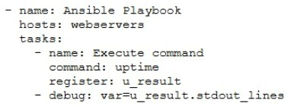
D. Disable the account
E. Run a port scan
F. Rotate the credentials
Answer:
DF
Question #300
(
Topic: Exam A
)
The following is a code excerpt of a playbook.yaml file:
Which of the following functions does this code perform?
A. Registers the variable needed to debug the web server stdout result
B. Executes the command to restart the web server and lists the result
C. Prints the amount of time the server has been online
D. Troubleshoots the web server configurations and standard output
Answer:
C
Question #301
(
Topic: Exam A
)
A healthcare provider's regulatory requirements include keeping patient data confidential, unaltered, retained for a minimum of five
years, and backed up to a bucket in the cloud. Which of the following methods meets these requirements?
A. Object Lock
B. Daily full backup
C. Data replication
D. Bulk recovery
Answer:
A
Question #302
(
Topic: Exam A
)
An engineer has an application running in the United States in a cloud environment. This application must be replicated into a United
Kingdom cloud environment. When the application is deployed to the United Kingdom environment, there are issues acquiring a virtual
machine with a GPU. Which of the following is the most likely reason for this issue?
A. The route tables are misconfigured and cannot connect to virtual machines
B. The API for creating virtual machines is being throttled
C. The United Kingdom region has an outage
D. The United Kingdom region does not have virtual machines that meet the requirements
E. The United Kingdom region cannot connect to the United States region
Answer:
D
Question #303
(
Topic: Exam A
)
A large financial corporation experienced a data breach. An investigation reveals that the attacker infiltrated the firewall via a vulnerability
and accessed different servers within the network. Which of the following security controls should the cloud security team implement to
prevent future breaches like this one?
A. An MFA solution
B. An IDS
C. A Zero Trust architecture
D. A NAC
Answer:
C
Question #304
(
Topic: Exam A
)
A cloud administrator must increase uptime for an application. Which of the following methods keeps costs to a minimum while
increasing uptime?
A. Deploying on-premises services
B. Deploying a geo-redundant cluster
C. Deploying services to a cold DR site
D. Deploying services to availability zones
Answer:
D
Question #305
(
Topic: Exam A
)
Which of the following technologies helps secure public-facing API endpoints?
A. DDoS protection
B. Vulnerability scanning
C. Data loss prevention
D. Intrusion detection systems
Answer:
A
Question #306
(
Topic: Exam A
)
An e-commerce business operates its web applications using a microservices-based architecture. These application instances run on
multiple VMs in the cloud and are interconnected through discovery. As the business grows, prioritizing rapid scaling will be crucial.
Which of the following best meets the business's scaling needs?
A. Manually tuning the VM size to meet demand based on estimates and projections
B. Configuring vertical scaling to increase system resources on a set schedule
C. Automatically provisioning more application instances when CPU usage hits a set threshold
D. Setting up a new colocated data center to handle extra load based on specific criteria
Answer:
C
Question #307
(
Topic: Exam A
)
A company needs an application to manage its CRM system with the least administrative overhead. Which of the following models is the
best for migrating the infrastructure to the cloud?
A. PaaS
B. SaaS
C. FaaS
D. IaaS
Answer:
B
Question #308
(
Topic: Exam A
)
Which of the following commands is used to deploy a container in which the image name is "working"?
A. $docker run -p 80:8080 -it working images.comptia.org/development:latest -e /bin/bash
B. $docker run -p 80:8080 -it images.comptia.org/working/production:latest -e /bin/bash
C. $docker run -p 80:8080 -it images.comptia.org/abcd123/working:latest -e /bin/bash
D. $docker run -p 80:8080 -it working.images.comptia.org/abcd12:latest -e /bin/bash
Answer:
C
Question #309
(
Topic: Exam A
)
A company uses two mobile applications. Application A is used in the United States market, and Application
В
is used in the European
Union market with GDPR restrictions. Both applications must comply with PCI standards. The company is consolidating both mobile
applications into a single application and must standardize its database back-end system. Which of the following is the best option to
provision the database for the consolidated mobile application?
A. Deploying one global database across multiple regions
B. Using two databases in the same region with different access controls
C. Implementing two databases in two different regions
D. Provisioning one database in one region with separate IAM permissions
Answer:
C
Question #310
(
Topic: Exam A
)

A company is migrating to a cloud. The company wants a solution that will help developers focus primarily on code rather than on
managing infrastructure. Which of the following best meets this need?
A. Deploying IaaS
B. Configuring FaaS
C. Subscribing to PaaS
D. Purchasing SaaS
Answer:
C
Question #311
(
Topic: Exam A
)
A cloud engineer wants resource-level visibility for billing reports. Which of the following should the cloud engineer configure?
A. Rightsizing
B. Invoicing
C. Reserve instances
D. Tagging
Answer:
D
Question #312
(
Topic: Exam A
)
A cloud administrator is troubleshooting an issue for a client. The client has the following capabilities:
•
Can access servers on the VPC, including servers on other subnets
•
Can ping other resources on the network
•
Can ping its own gateway
However, the client cannot reach the internet Which of the following is most likely the cause?
A. The gateway is missing a route
B. The client has a duplicate IP address
C. The DHCP server is not functioning properly
D. The network has too much latency.
Answer:
A
Question #313
(
Topic: Exam A
)
A company wants to offer customers an interactive experience through its website to solve common issues. Which of the following would
most likely provide this feature?
A. Search engine
B. Generative AI
C. Help page
D. Text recognition
Answer:
B
Question #314
(
Topic: Exam A
)
A company recently migrated to a public cloud provider. The company's computer incident response team needs to configure native
cloud services for detailed logging. Which of the following should the team implement on each cloud service to support root cause
analysis of past events?
(
Choose two.
)
A. Log retention
B. Tracing
C. Log splicing
D. Log rotation
E. Hashing
F. Encryption
Answer:
AB

Page: 1 / 1 Total 314 questions

